Assignment 1
Registration ID: 260640160209
PNR: 260740150018
Name: PRATIK SUNIL ABHANG

Question No. 1
Question
Write a C++ program to create a namespace named Math that contains a function void square(int) to calculate the square of a number. Access the function using the scope resolution operator.
Program
#include <iostream>
using namespace std;

namespace Math
{
void Square(int n)
{
cout << "Square = " << n * n;
}
}

int main()
{
int num;

cout << "Enter a number: ";
cin >> num;

Math::Square(num);

return 0;
}

Input & Output
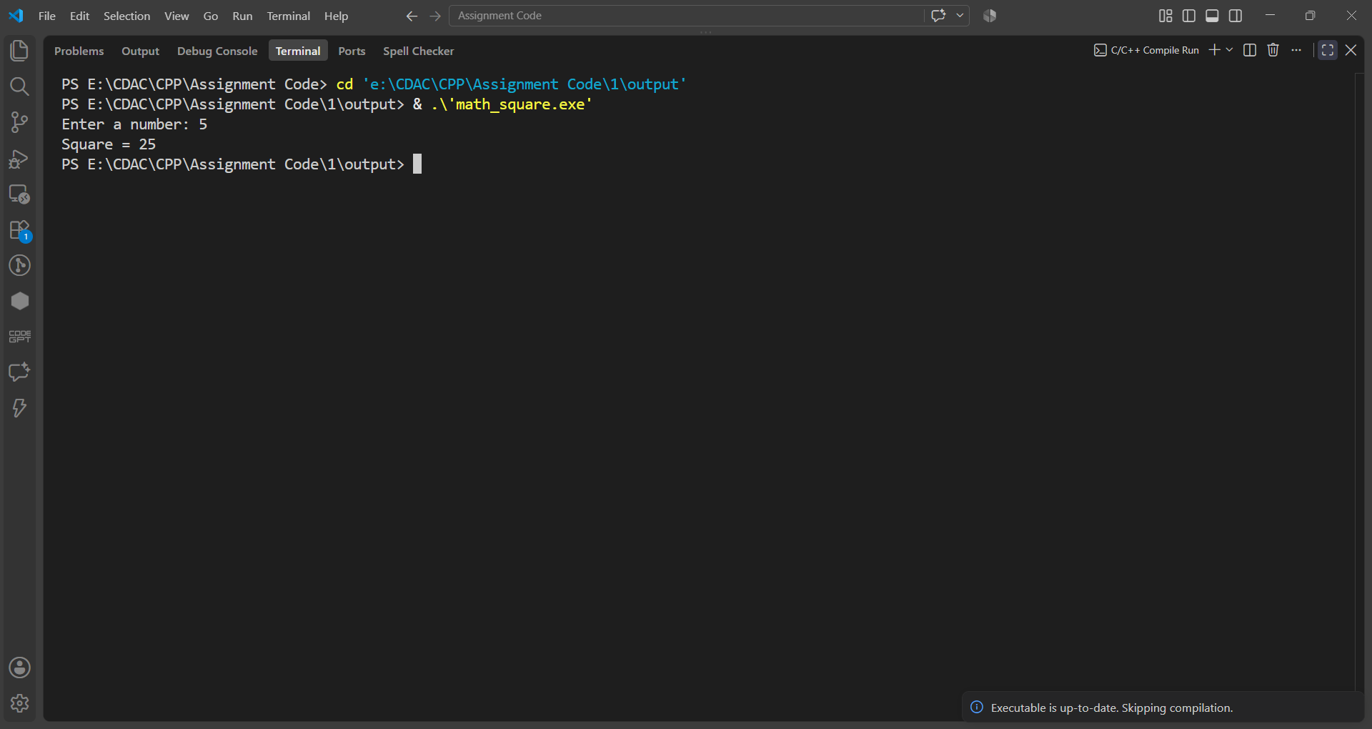

Question No. 2
Question
Create a namespace named Calculator containing the following functions:
• add()
• subtract()
• multiply()
• divide()
Write a menu-driven program to perform arithmetic operations using namespace functions.
Program
#include <iostream>
using namespace std;

namespace Calculator
{
void Add(int a, int b)
{
cout << "Addition = " << a + b << endl;
}

void Subtract(int a, int b)
{
cout << "Subtraction = " << a - b << endl;
}

void Multiply(int a, int b)
{
cout << "Multiplication = " << a * b << endl;
}

void Divide(int a, int b)
{
if (b == 0)
cout << "Division by zero is not possible";
else
cout << "Division = " << (float)a / b;
}
}

int main()
{
int a, b, choice;

cout << "Enter first number: ";
cin >> a;

cout << "Enter second number: ";
cin >> b;

cout << "\n1. Addition";
cout << "\n2. Subtraction";
cout << "\n3. Multiplication";
cout << "\n4. Division";
cout << "\nEnter your choice: ";
cin >> choice;

switch (choice)
{
case 1:
Calculator::Add(a, b);
break;

case 2:
Calculator::Subtract(a, b);
break;

case 3:
Calculator::Multiply(a, b);
break;

case 4:
Calculator::Divide(a, b);
break;

default:
cout << "Invalid choice";
}

return 0;
}
Input & Output
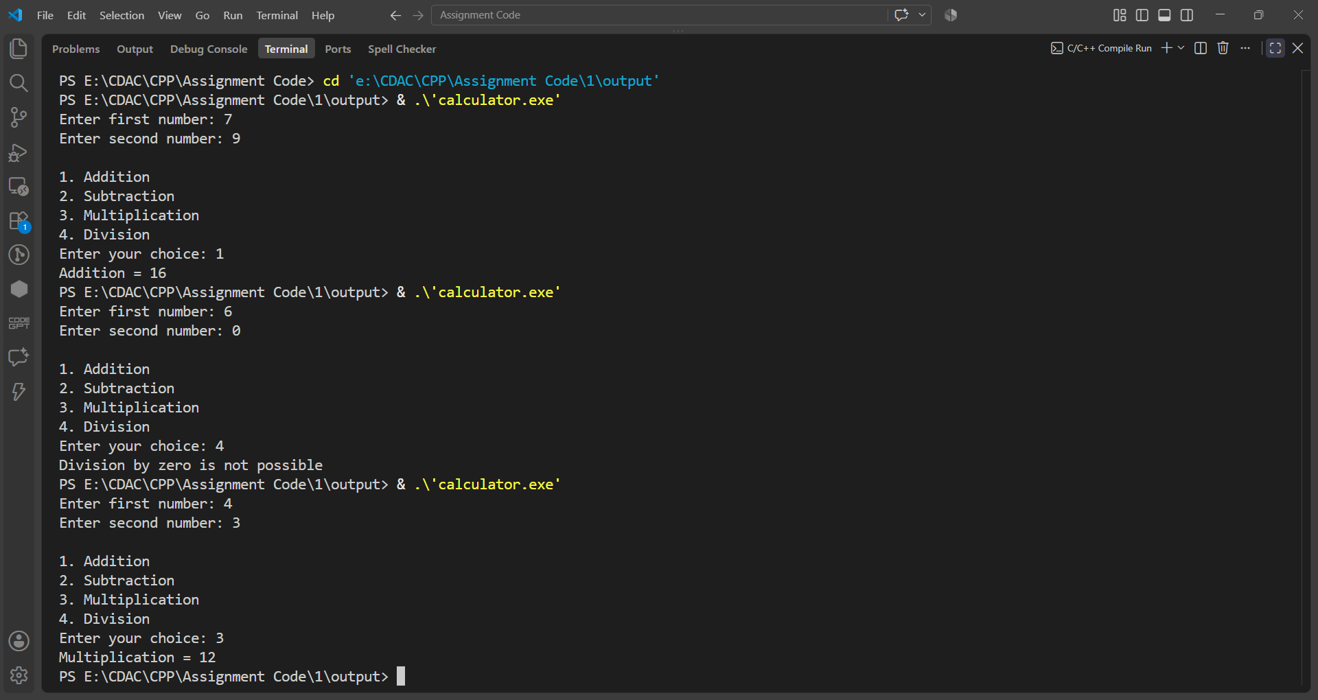

Question No. 3
Question
Create two namespaces:
Rectangle
Circle
The Rectangle namespace should calculate area of rectangle.
The Circle namespace should calculate area of circle.
Allow the user to select which area to calculate.
Program
#include <iostream>
using namespace std;

namespace Rectangle
{
void Area(float length, float width)
{
cout << "Area of Rectangle = " << length * width;
}
}

namespace Circle
{
void Area(float radius)
{
cout << "Area of Circle = " << 3.14 * radius * radius;
}
}

int main()
{
int choice;
float length, width, radius;

cout << "1. Rectangle";
cout << "\n2. Circle";
cout << "\nEnter your choice: ";
cin >> choice;

switch (choice)
{
case 1:
cout << "Enter length: ";
cin >> length;

cout << "Enter width: ";
cin >> width;

Rectangle::Area(length, width);
break;

case 2:
cout << "Enter radius: ";
cin >> radius;

Circle::Area(radius);
break;

default:
cout << "Invalid choice";
}

return 0;
}

Input & Output
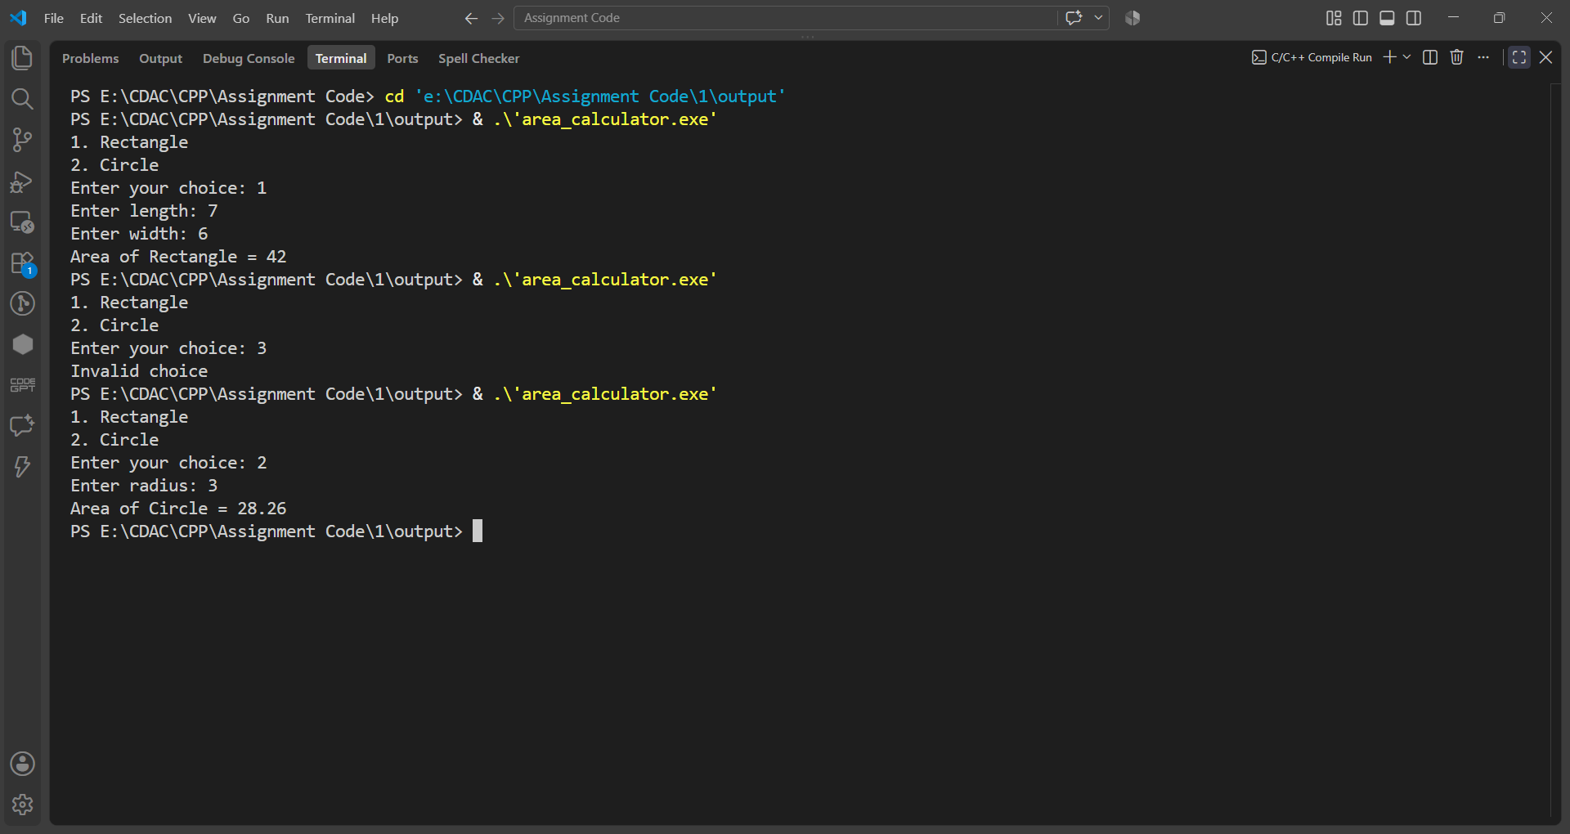

Question No. 4
Question
Create two namespaces:
namespace India
namespace USA
Each namespace should have a function named currency().
Program
#include <iostream>
using namespace std;

namespace India
{
void Currency()
{
cout << "Currency of India is Rupee (INR)";
}
}

namespace USA
{
void Currency()
{
cout << "Currency of USA is Dollar (USD)";
}
}

int main()
{
int choice;
cout << "1. India";
cout << "\n2. USA";
cout << "\nEnter your choice: ";
cin >> choice;

switch (choice)
{
case 1:
India::Currency();
break;

case 2:
USA::Currency();
break;

default:
cout << "Invalid choice";
}

return 0;
}
Input & Output
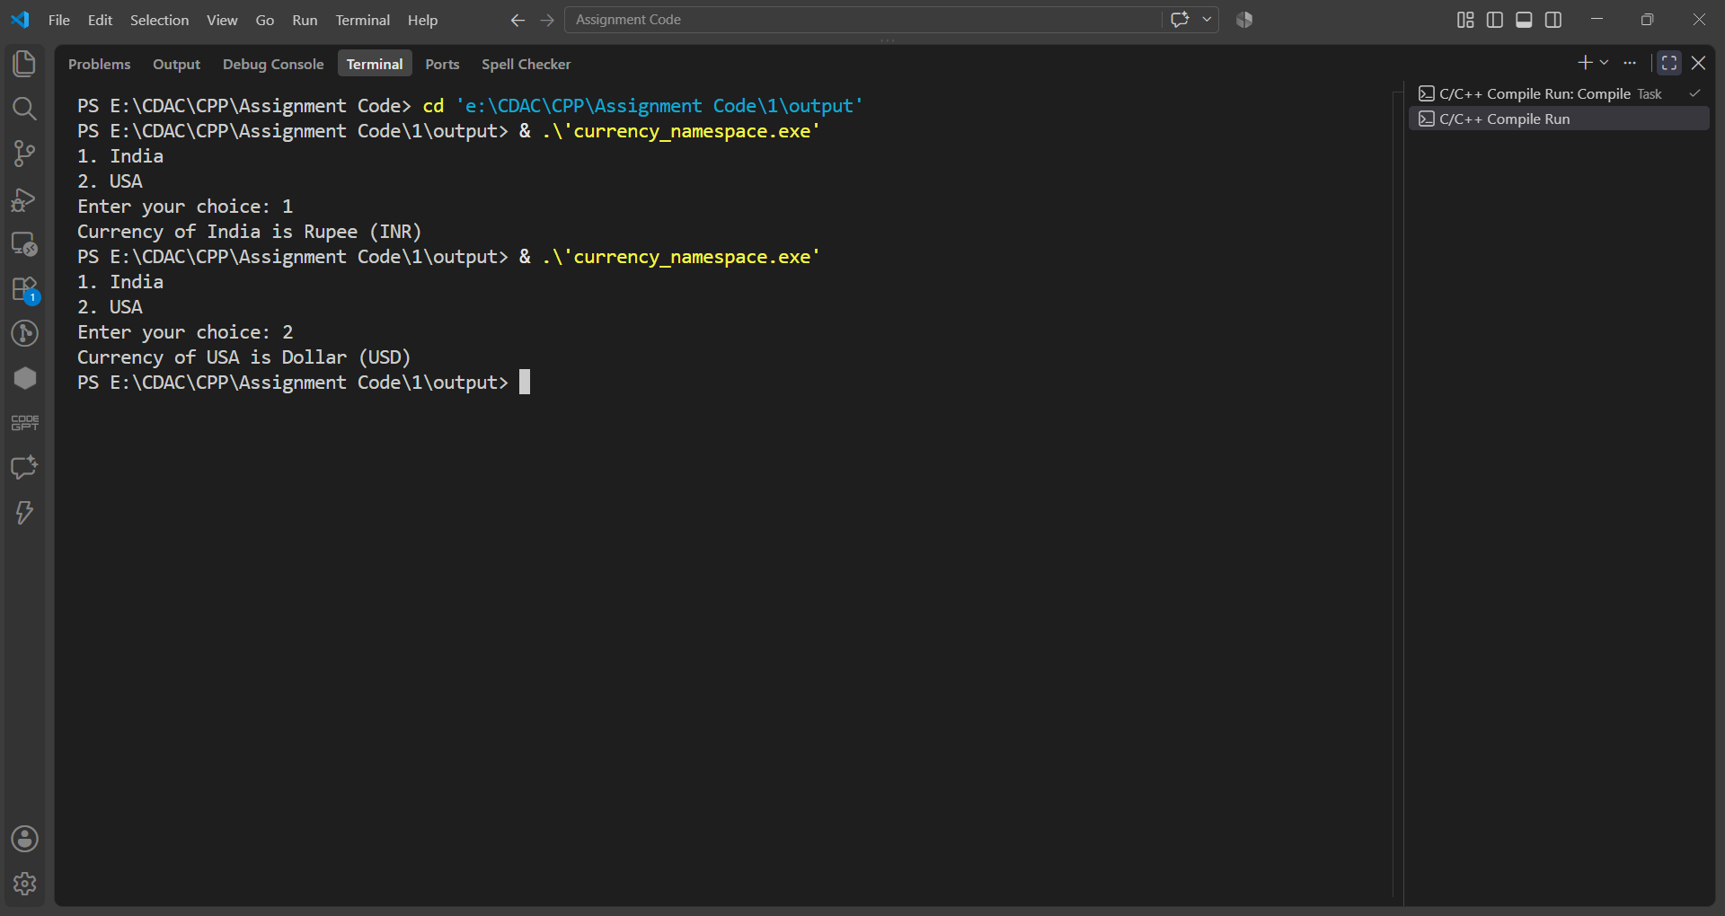

Question No. 5
Question
Create a namespace named Student having
• rollNo
• name
• display()
Use the using namespace directive to access members without using scope resolution operator.
Program
#include <iostream>
using namespace std;

namespace Student
{
int RollNo;
char Name[30];

void Display()
{
cout << "Roll No = " << RollNo << endl;
cout << "Name = " << Name;
}
}

using namespace Student;

int main()
{
cout << "Enter Roll No: ";
cin >> RollNo;

cout << "Enter Name: ";
cin >> Name;

Display();

return 0;
}

Input & Output
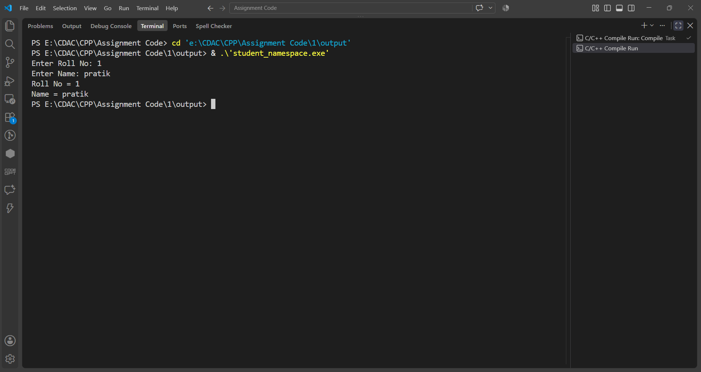

Question No. 6
Question
Write a C++ program that dynamically allocates memory for storing the marks of a student based on the number of subjects entered by the user.
The program should perform the following tasks:
1. Accept the number of subjects from the user.
2. Dynamically allocate memory to store the marks of all subjects.
3. Accept the marks for each subject.
4. Display the marks of all subjects.
5. Calculate and display the total (sum) of the marks.
6. Calculate and display the average marks obtained.
7. Deallocate the dynamically allocated memory before the program terminates to avoid memory leaks.
Program
#include <iostream>
using namespace std;

int main()
{
int n, i;
int total = 0;
float average;

cout << "Enter number of subjects: ";
cin >> n;

int *marks = new int[n];

for(i = 0; i < n; i++)
{
cout << "Enter marks: ";
cin >> marks[i];
}

cout << "\nMarks are:\n";

for(i = 0; i < n; i++)
{
cout << marks[i] << endl;
total = total + marks[i];
}

average = (float)total / n;
cout << "Total = " << total << endl;
cout << "Average = " << average << endl;

delete[] marks;

return 0;
}
Input & Output
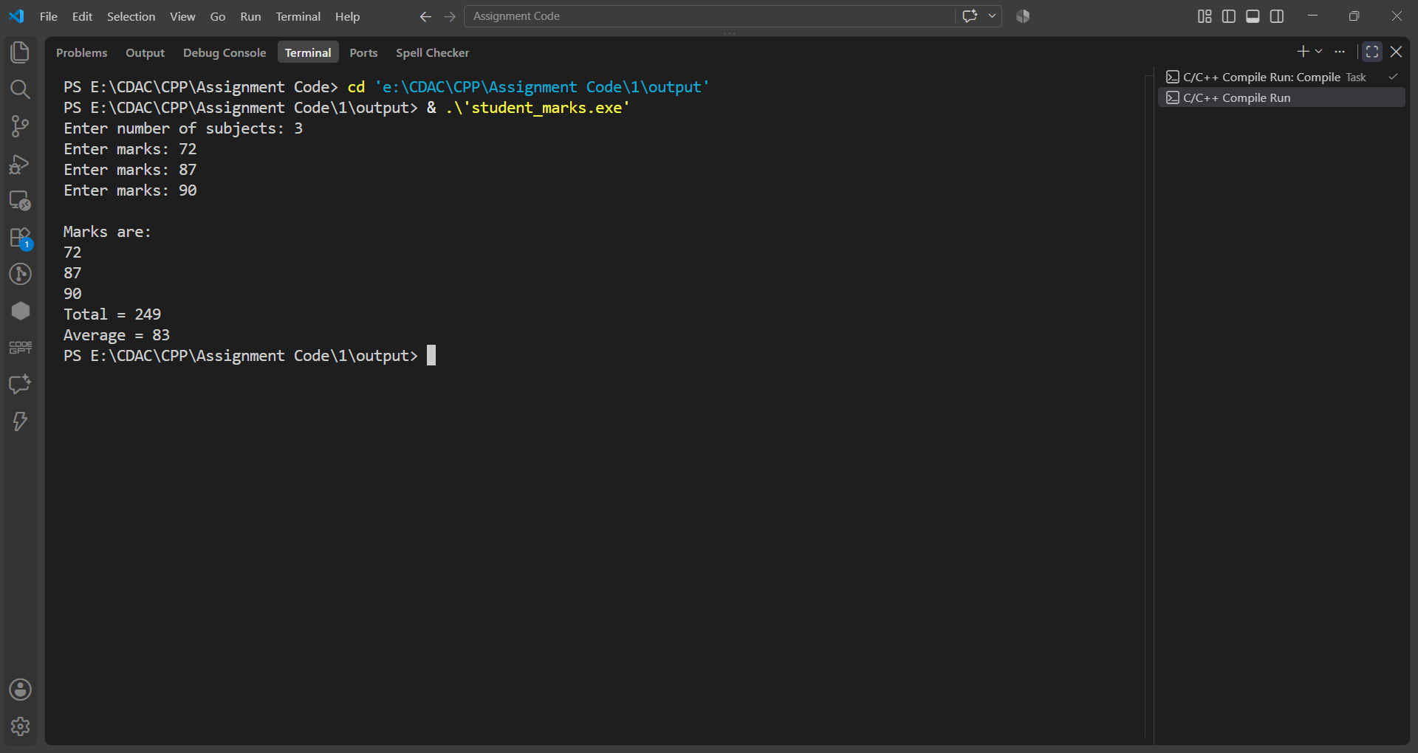

Question No. 7
Question
Write a C++ program that dynamically allocates memory for a 2D array to store the marks of multiple students in multiple subjects.
The program should perform the following tasks:
1. Accept the number of students from the user.
2. Accept the number of subjects from the user.
3. Dynamically allocate memory for a 2D array of size Students × Subjects.
4. Accept the marks of each student in every subject.
5. Display the marks in tabular format.
6. Calculate and display the total and average marks for each student.
7. Calculate and display the highest mark obtained among all students.
8. Deallocate all dynamically allocated memory before the program terminates to prevent memory leaks.
Program
#include <iostream>
using namespace std;

int main()
{
int students, subjects, i, j;
int total, highest = 0;
float average;

cout << "Enter number of students: ";
cin >> students;

cout << "Enter number of subjects: ";
cin >> subjects;

int **marks = new int*[students];

for(i = 0; i < students; i++)
{
marks[i] = new int[subjects];
}

for(i = 0; i < students; i++)
{
cout << "Enter marks of Student " << i + 1 << endl;

for(j = 0; j < subjects; j++)
{
cin >> marks[i][j];

if(marks[i][j] > highest)
{
highest = marks[i][j];
}
}
}

cout << "\nMarks\n";

for(i = 0; i < students; i++)
{
total = 0;

cout << "Student " << i + 1 << ": ";

for(j = 0; j < subjects; j++)
{
cout << marks[i][j] << " ";
total = total + marks[i][j];
}

average = (float)total / subjects;

cout << " Total = " << total;
cout << " Average = " << average << endl;
}

cout << "\nHighest Mark = " << highest << endl;

for(i = 0; i < students; i++)
{
delete[] marks[i];
}

delete[] marks;

return 0;
}

Input & Output
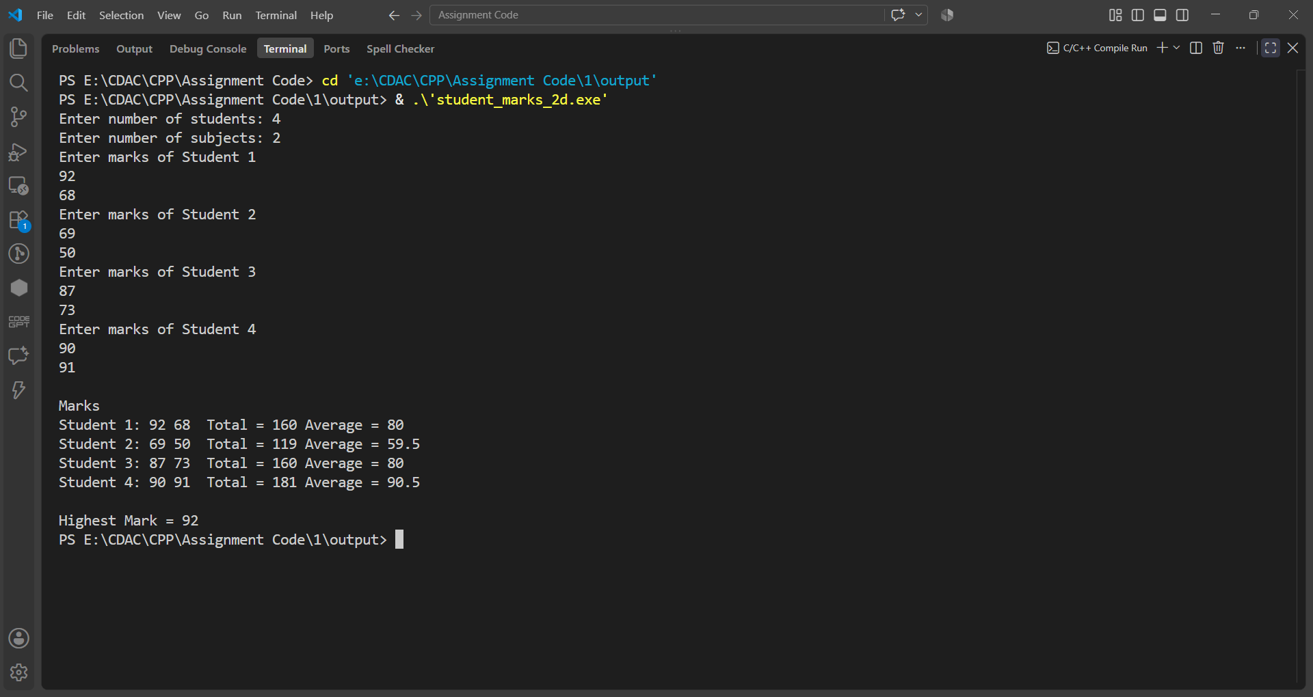

Assignment 2
Name: PRATIK SUNIL ABHANG
PNR: 260740150018
Registration ID: 260640160209

Question No. 1
Question
Write a C++ program to create an inline function that calculates the square of a number. Accept the number from the user and display the square.
Program
#include<iostream>
using namespace std;

inline int Square(int n)
{
return n * n;
}

int main()
{
int n, ans;

cout<<"Enter Number: ";
cin>>n;

ans = Square(n);

cout<<"Square = "<<ans;

return 0;
}

Input & Output
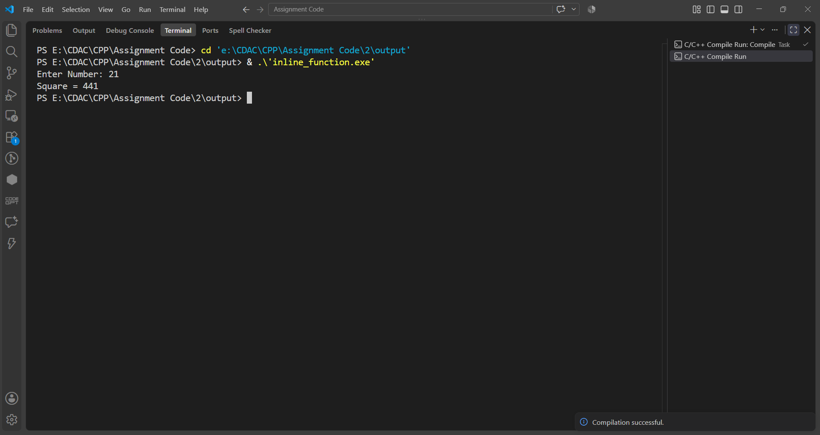

Question No. 2
Question
Write a C++ program to find the factorial of a given number using a recursive function.
Program
#include<iostream>
using namespace std;

int Factorial(int n)
{
if(n==0 || n==1)
{
return 1;
}

return n * Factorial(n-1);
}

int main()
{
int n, ans;

cout<<"Enter Number: ";
cin>>n;

ans = Factorial(n);

cout<<"Factorial = "<<ans;

return 0;
}
Input & Output
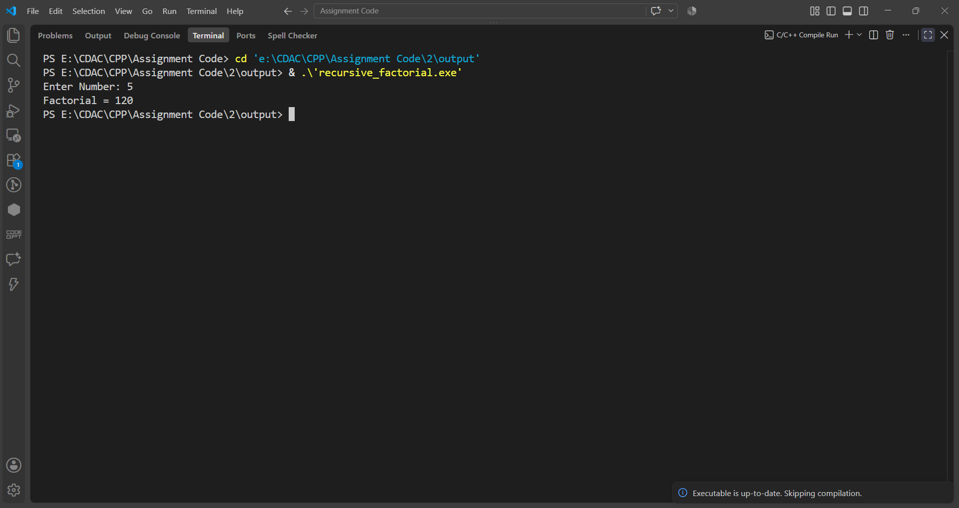

Question No. 3
Question
Write a C++ program to print the first N Fibonacci numbers using recursion.
Program
#include<iostream>
using namespace std;

int Fibonacci(int n)
{
if(n==0)
{
return 0;
}

if(n==1)
{
return 1;
}

return Fibonacci(n-1) + Fibonacci(n-2);
}

int main()
{
int n;

cout<<"Enter N: ";
cin>>n;

cout<<"Fibonacci Series: ";

for(int i=0; i<n; i++)
{
cout<<Fibonacci(i)<<" ";
}

return 0;
}

Input & Output
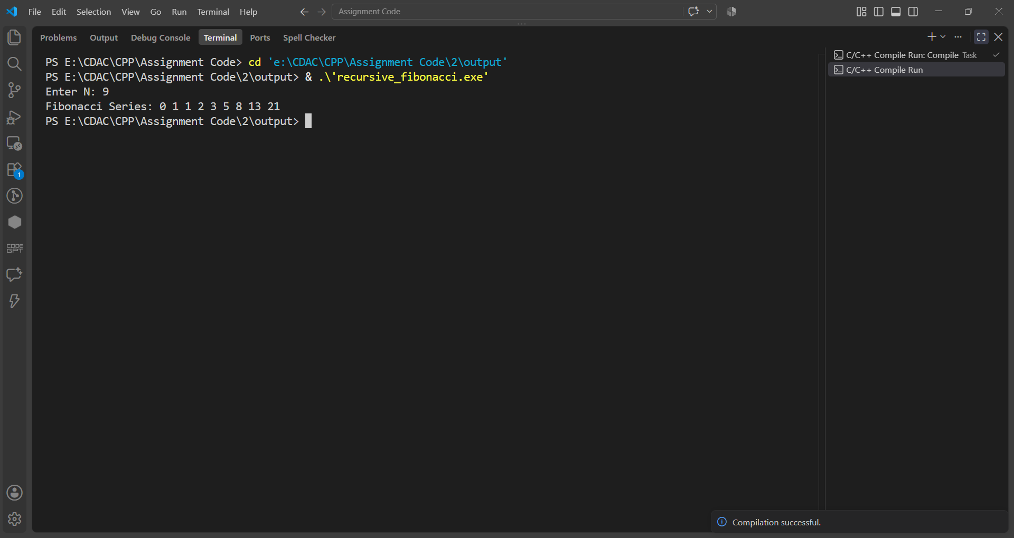

Question No. 4
Question
Write a C++ program to calculate the sum of digits of a given number using recursion.
Program
#include<iostream>
using namespace std;

int SumOfDigits(int n)
{
int r = n % 10;
int d = n / 10;
if(n==0)
{
return 0;
}

return r + SumOfDigits(d);
}

int main()
{
int n, ans;

cout<<"Enter Number: ";
cin>>n;

ans = SumOfDigits(n);

cout<<"Sum Of Digits = "<<ans;

return 0;
}

Input & Output
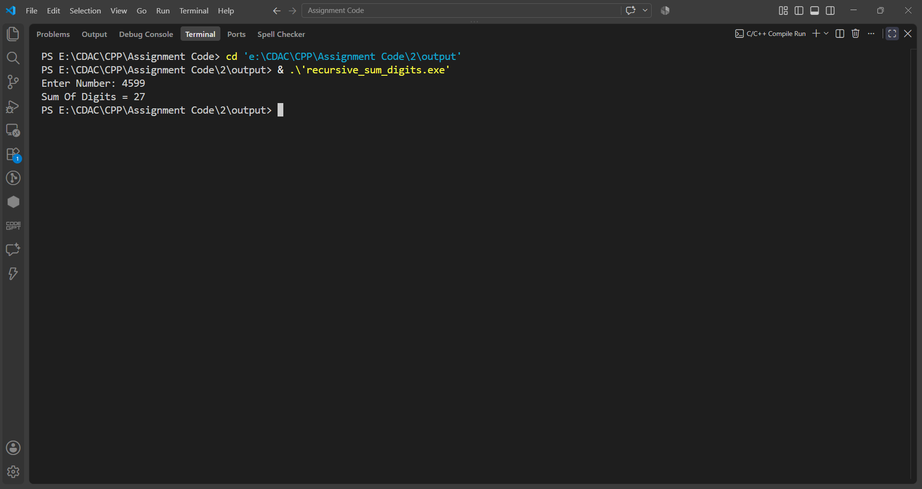

Question No. 5
Question
Write a C++ program to overload a function named Area() to calculate the area of a circle and the area of a rectangle.
Program
#include<iostream>
using namespace std;

void Area(int r, float &a, float &c)
{
a = 3.14 * r * r;
c = 2 * 3.14 * r;
}

int main()
{
int r;
float a, c;

cout<<"Enter Radius: ";
cin>>r;

Area(r, a, c);

cout<<"Area = "<<a<<endl;
cout<<"Circumference = "<<c;

return 0;
}

Input & Output
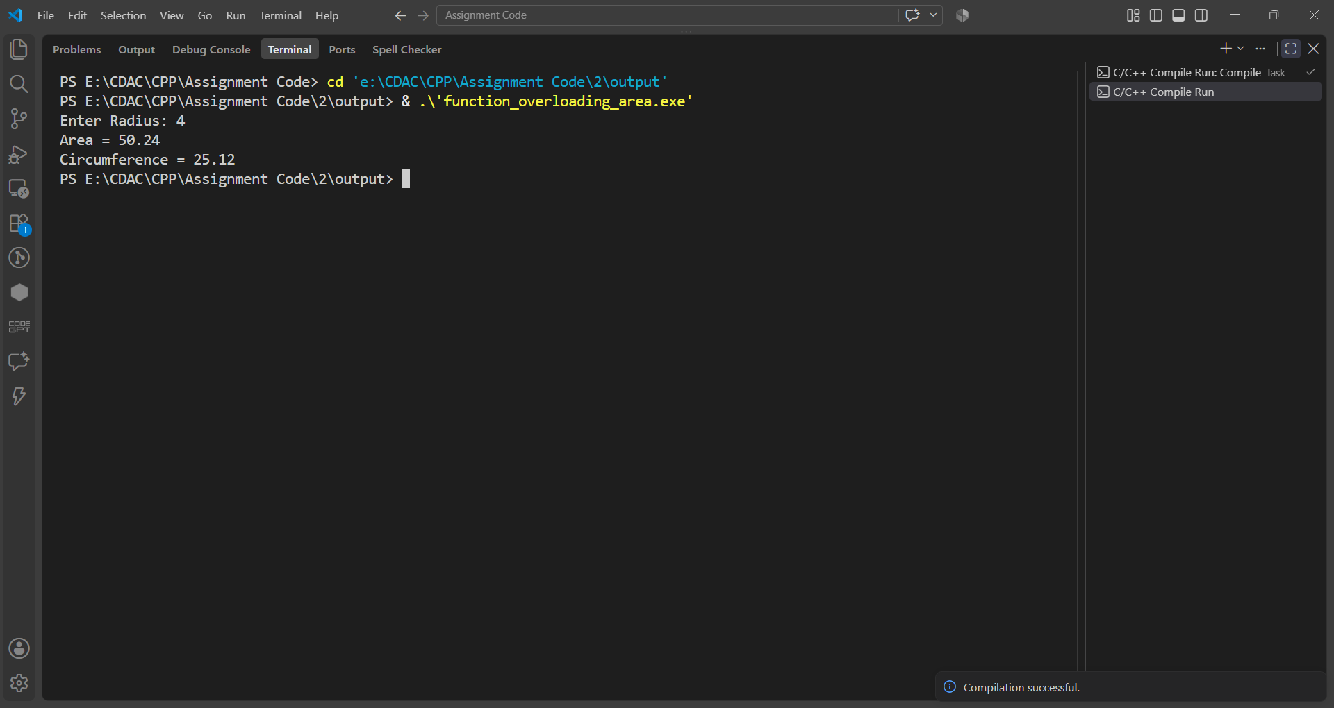

Question No. 6
Question
Write overloaded functions named Maximum() to find the largest among two integers, three integers, and two floating-point numbers.
Program
#include<iostream>
using namespace std;

int Maximum(int a,int b)
{
if(a>b)
return a;
else
return b;
}

int Maximum(int a,int b,int c)
{
if(a>b && a>c)
return a;
else if(b>c)
return b;
else
return c;
}

float Maximum(float a,float b)
{
if(a>b)
return a;
else
return b;
}

int main()
{
int a,b,c;
float x,y;

cout<<"Enter Two Integers: ";
cin>>a>>b;

cout<<"Maximum = "<<Maximum(a,b)<<endl;

cout<<"Enter Three Integers: ";
cin>>a>>b>>c;

cout<<"Maximum = "<<Maximum(a,b,c)<<endl;

cout<<"Enter Two Float Numbers: ";
cin>>x>>y;

cout<<"Maximum = "<<Maximum(x,y);

return 0;
}

Input & Output
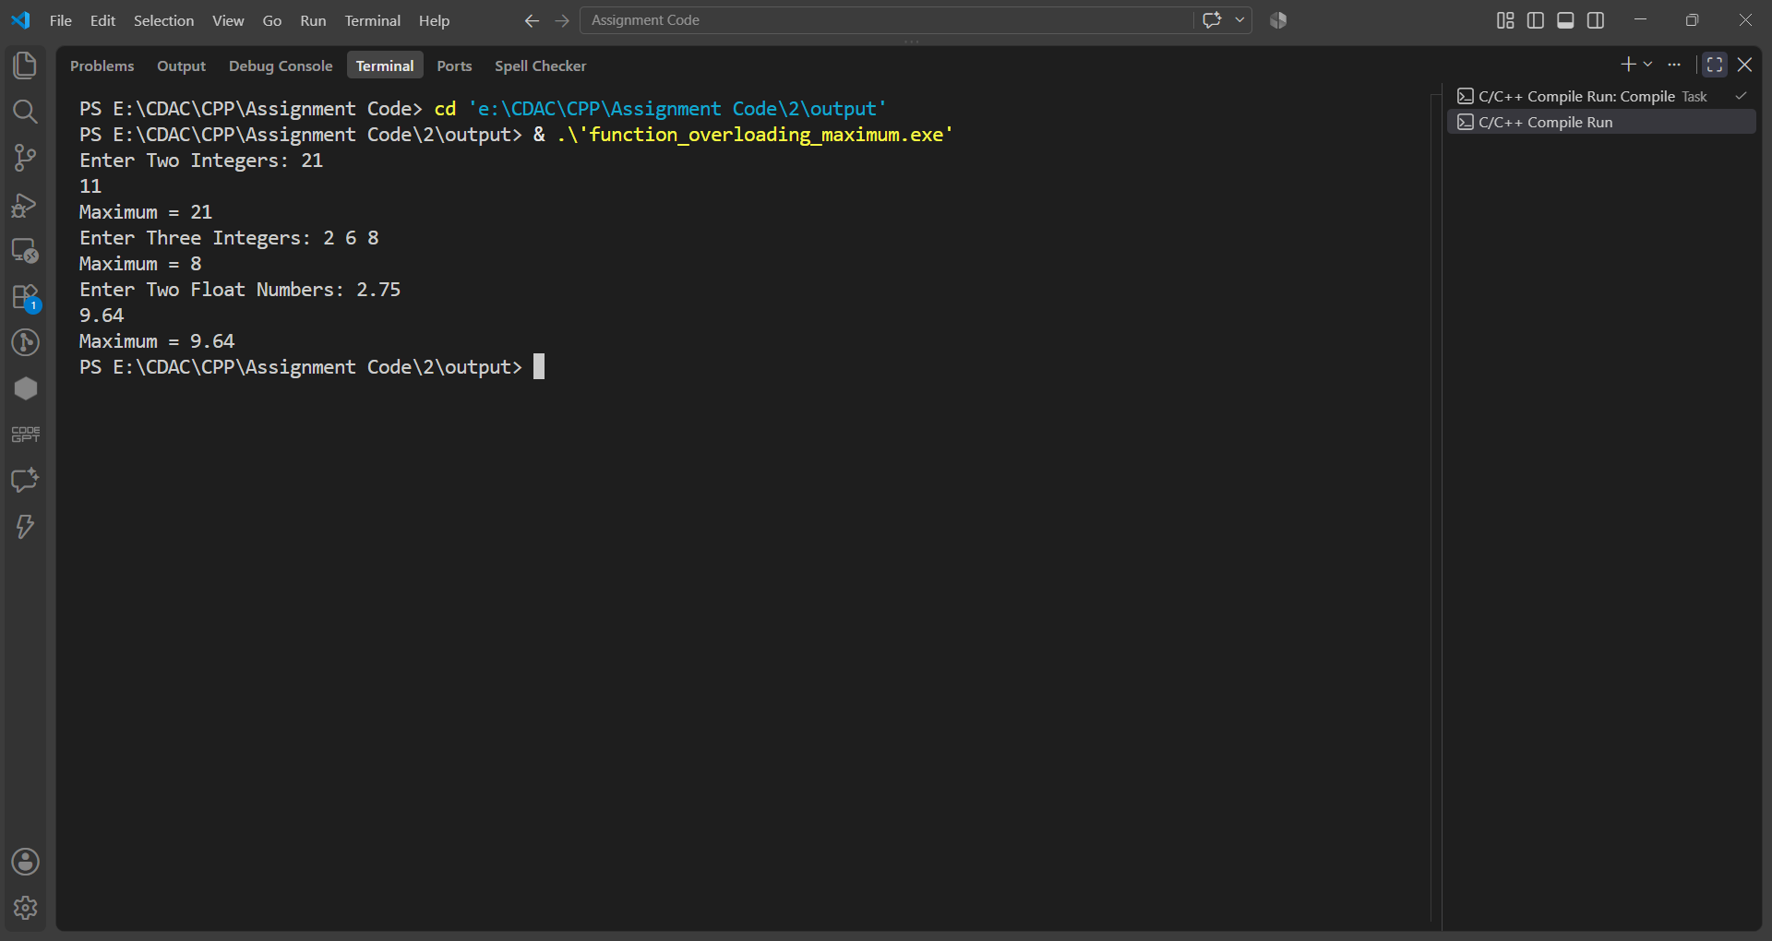

Question No. 7
Question
Accept two numbers from user pass these numbers to Swap function. Function should interchange the values.
Program
#include<iostream>
using namespace std;

void Swap(int &a,int &b)
{
int temp;
temp=a;
a=b;
b=temp;
}

int main()
{
int a,b;
cout<<"Enter Two Numbers: ";
cin>>a>>b;
Swap(a,b);
cout<<"After Swap"<<endl;
cout<<"First Number = "<<a<<endl;
cout<<"Second Number = "<<b;
return 0;
}

Input & Output
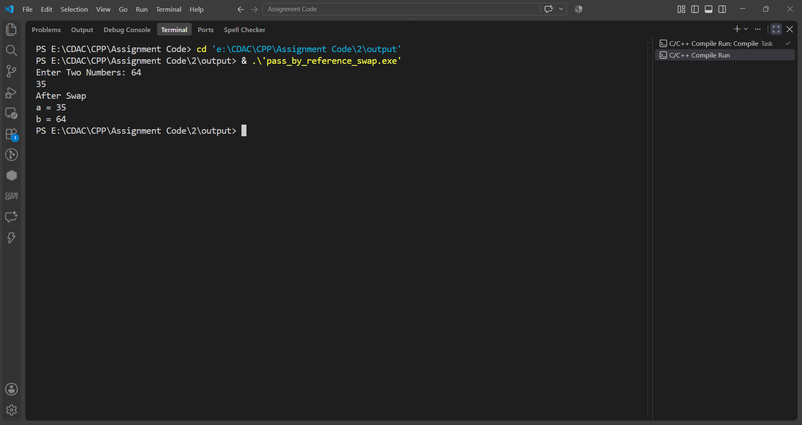

Question No. 8
Question
Write a C++ program to calculate simple interest using a function with default arguments. Use the default rate of interest as 8%.
Program
#include<iostream>
using namespace std;

float CalculateSI(float p,float t,float r=8)
{
return (p*t*r)/100;
}

int main()
{
float p,t,r;

cout<<"Enter Principal: ";
cin>>p;
cout<<"Enter Years: ";
cin>>t;

cout<<"Simple Interest (Default Rate 8%) = "<<CalculateSI(p,t)<<endl;

cout<<"Enter Rate: ";
cin>>r;

cout<<"Simple Interest (Custom Rate) = "<<CalculateSI(p,t,r);

return 0;
}

Input & Output
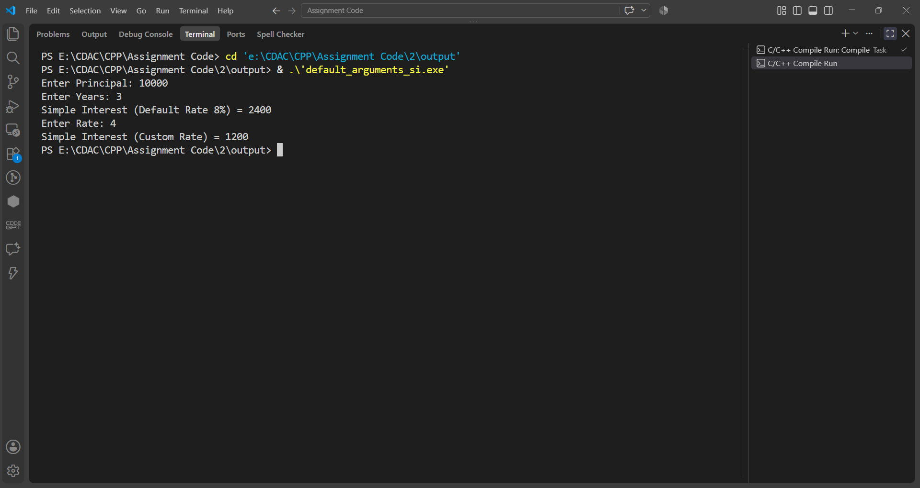

Question No. 9
Question
Write a C++ program using a variable parameter list to calculate the sum of any number of integers.
Program
#include<iostream>
#include<cstdarg>
using namespace std;

int Sum(int n,...)
{
va_list list;
va_start(list,n);
int ans=0;
for(int i=0;i<n;i++)
ans+=va_arg(list,int);
va_end(list);
return ans;
}

int main()
{
cout<<"Sum = "<<Sum(3,10,20,30)<<endl;
cout<<"Sum = "<<Sum(5,2,4,6,8,10);
return 0;
}

Input & Output
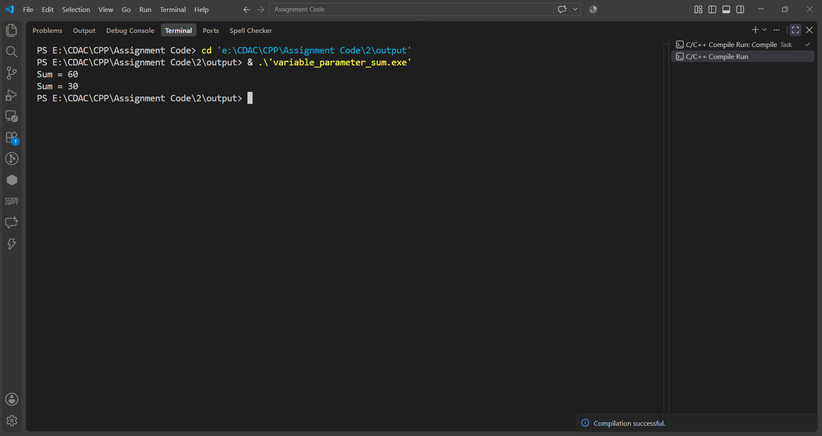

Assignment 3
Name: PRATIK SUNIL ABHANG
PNR: 260740150018
Registration ID: 260640160209

Question No. 1
Question
Implement Date class with data members day, month and year. Implement Accept(), Display(), overloaded Display(char) and CheckLeapYear().
Program
#include<iostream>
using namespace std;

class Date
{
int day,month,year;

public:
void Accept()
{
cout<<"Enter Day: ";
cin>>day;
cout<<"Enter Month: ";
cin>>month;
cout<<"Enter Year: ";
cin>>year;
}

void Display()
{
cout<<"Date = "<<day<<"/"<<month<<"/"<<year<<endl;
}

void Display(char ch)
{
cout<<"Date = "<<day<<ch<<month<<ch<<year<<endl;
}

void CheckLeapYear()
{
if((year%400==0)||(year%4==0&&year%100!=0))
cout<<"Leap Year";
else
cout<<"Not Leap Year";
}
};

int main()
{
Date d;
d.Accept();
d.Display();
d.Display('-');
d.CheckLeapYear();
return 0;
}

Input & Output
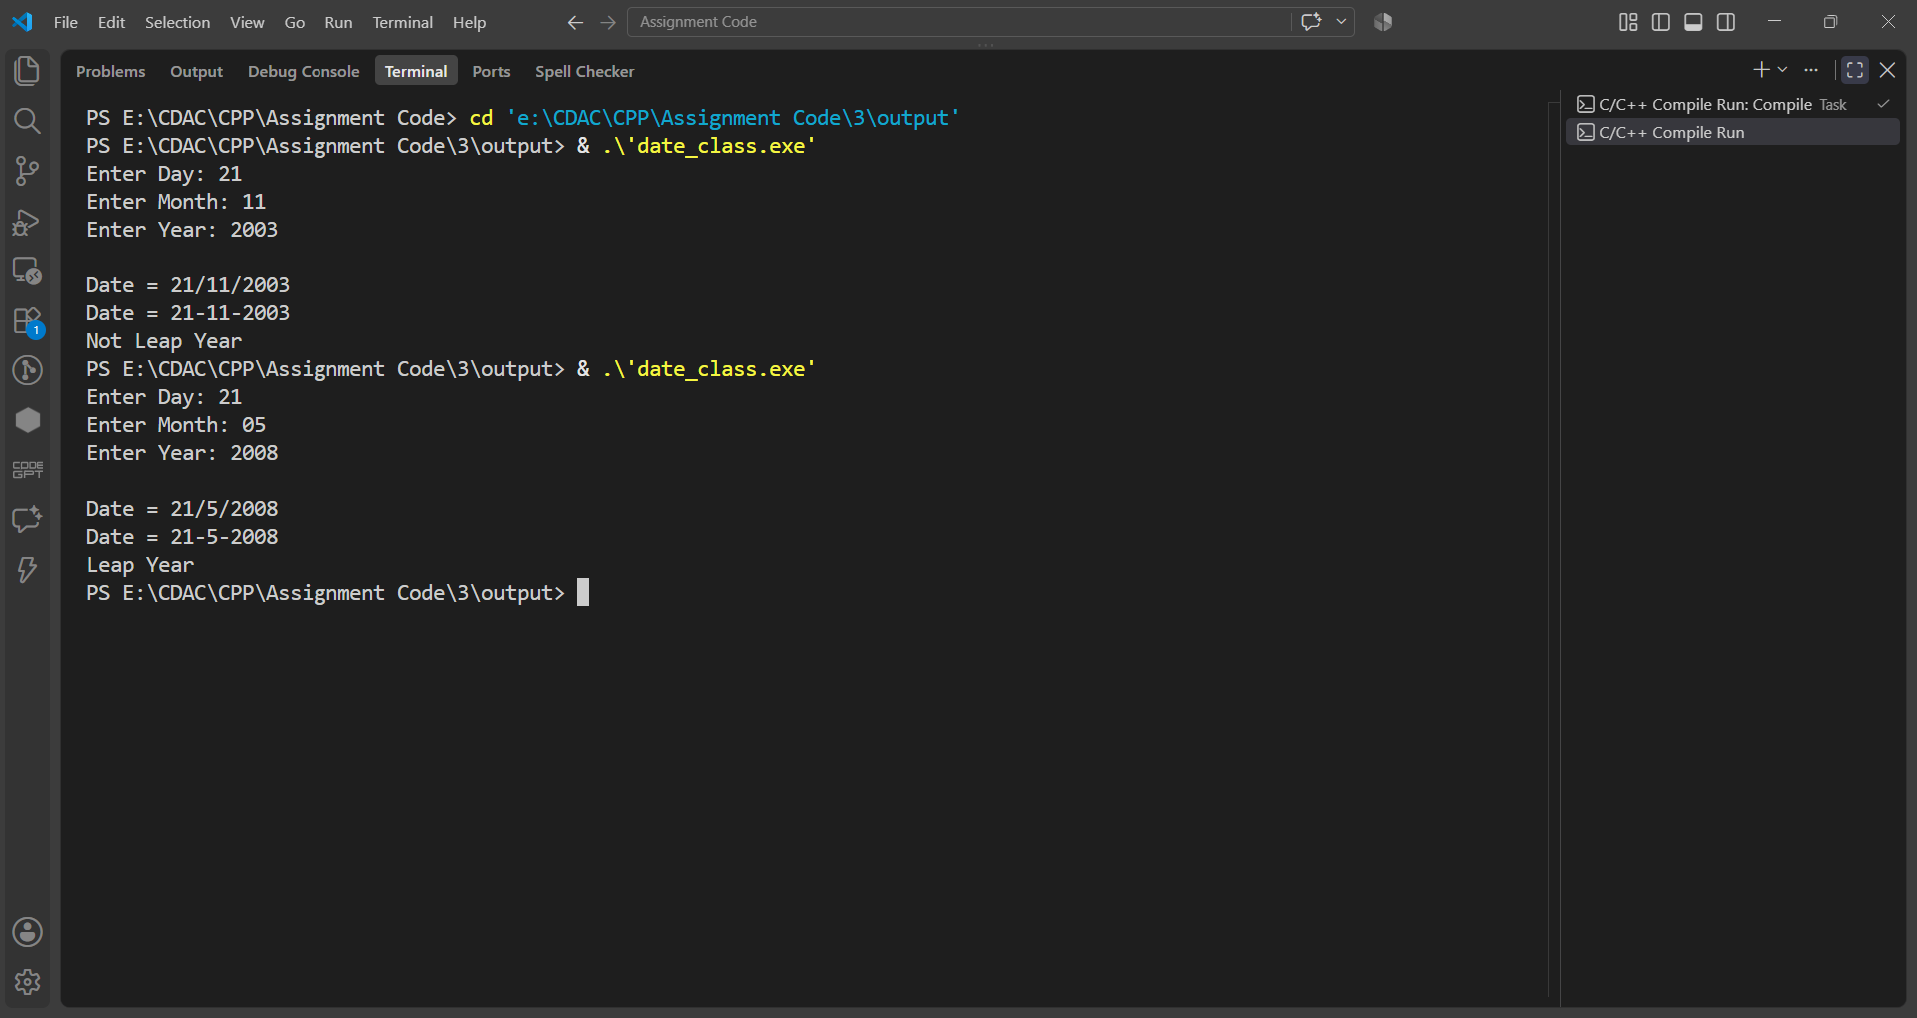

Question No. 2
Question
Implement Complex class with data members real and img. Implement Accept(), Display() and AddComplexNumbers().
Program
#include<iostream>
using namespace std;

class Complex
{
int real,img;

public:
void Accept()
{
cout<<"Enter Real Part: ";
cin>>real;
cout<<"Enter Imaginary Part: ";
cin>>img;
}

void Display()
{
cout<<"Complex Number = "<<real<<" + "<<img<<"i"<<endl;
}

void AddComplexNumbers(Complex c1,Complex c2)
{
real=c1.real+c2.real;
img=c1.img+c2.img;
}
};

int main()
{
Complex c1,c2,c3;

cout<<"First Complex Number"<<endl;
c1.Accept();

cout<<"Second Complex Number"<<endl;
c2.Accept();

c3.AddComplexNumbers(c1,c2);

cout<<"Result"<<endl;
c3.Display();

return 0;
}
Input & Output
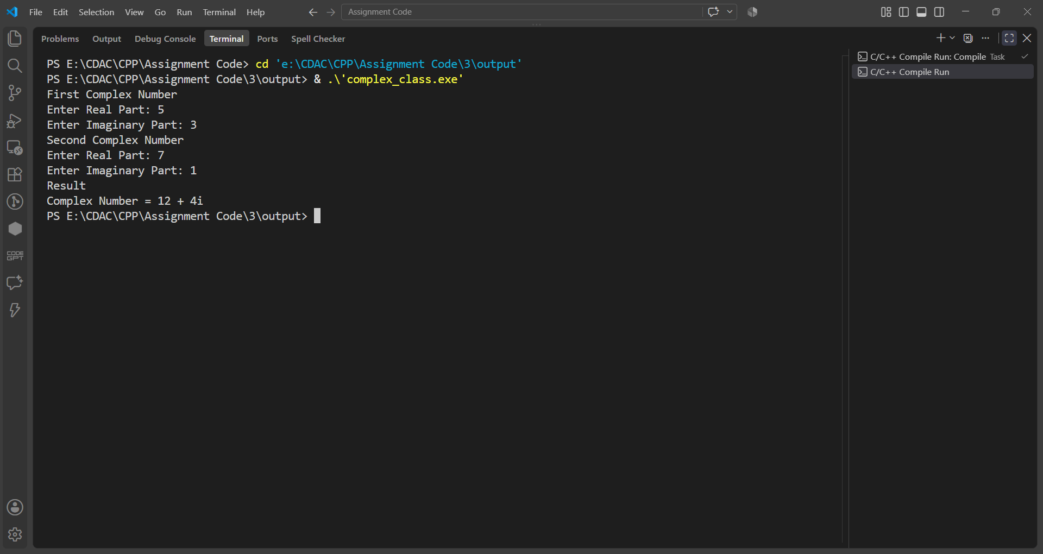

Question No. 3
Question
Create a LibraryBook class containing Book ID, Book Name, Author Name and Price. Implement Accept(), Display() and give 10% discount to every book.
Program
#include<iostream>
using namespace std;

class LibraryBook
{
int bookId;
char bookName[50];
char authorName[50];
float price;

public:
void Accept()
{
cout<<"Enter Book ID: ";
cin>>bookId;
cout<<"Enter Book Name: ";
cin>>bookName;
cout<<"Enter Author Name: ";
cin>>authorName;
cout<<"Enter Price: ";
cin>>price;
}

void Display()
{
cout<<"Book ID = "<<bookId<<endl;
cout<<"Book Name = "<<bookName<<endl;
cout<<"Author Name = "<<authorName<<endl;
cout<<"Price = "<<price<<endl;
price = price - (price*10/100);
cout<<"Price After 10% Discount = "<<price;
}
};

int main()
{
LibraryBook b;
b.Accept();
cout<<endl;
b.Display();
return 0;
}

Input & Output
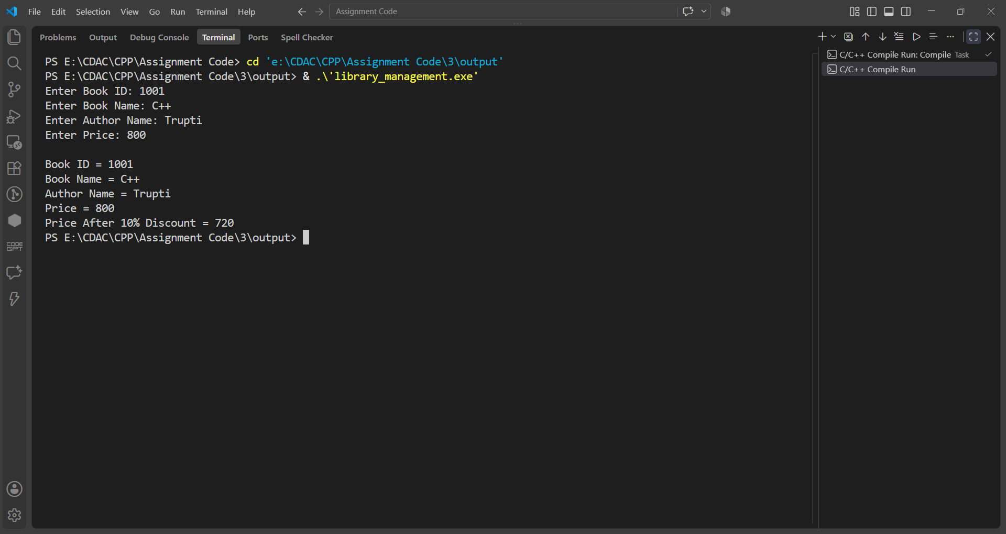

Question No. 4
Question
Create a Box class with data members length, width and height. Implement Accept(), Display() and CalculateVolume() functions.
Program
#include<iostream>
using namespace std;

class Box
{
int length,width,height;

public:
void Accept()
{
cout<<"Enter Length: ";
cin>>length;
cout<<"Enter Width: ";
cin>>width;
cout<<"Enter Height: ";
cin>>height;
}

void Display()
{
cout<<"Length = "<<length<<endl;
cout<<"Width = "<<width<<endl;
cout<<"Height = "<<height<<endl;
}

void CalculateVolume()
{
int volume;
volume = length * width * height;
cout<<"Volume = "<<volume;
}
};

int main()
{
Box b;
b.Accept();
cout<<endl;
b.Display();
b.CalculateVolume();
return 0;
}

Input & Output
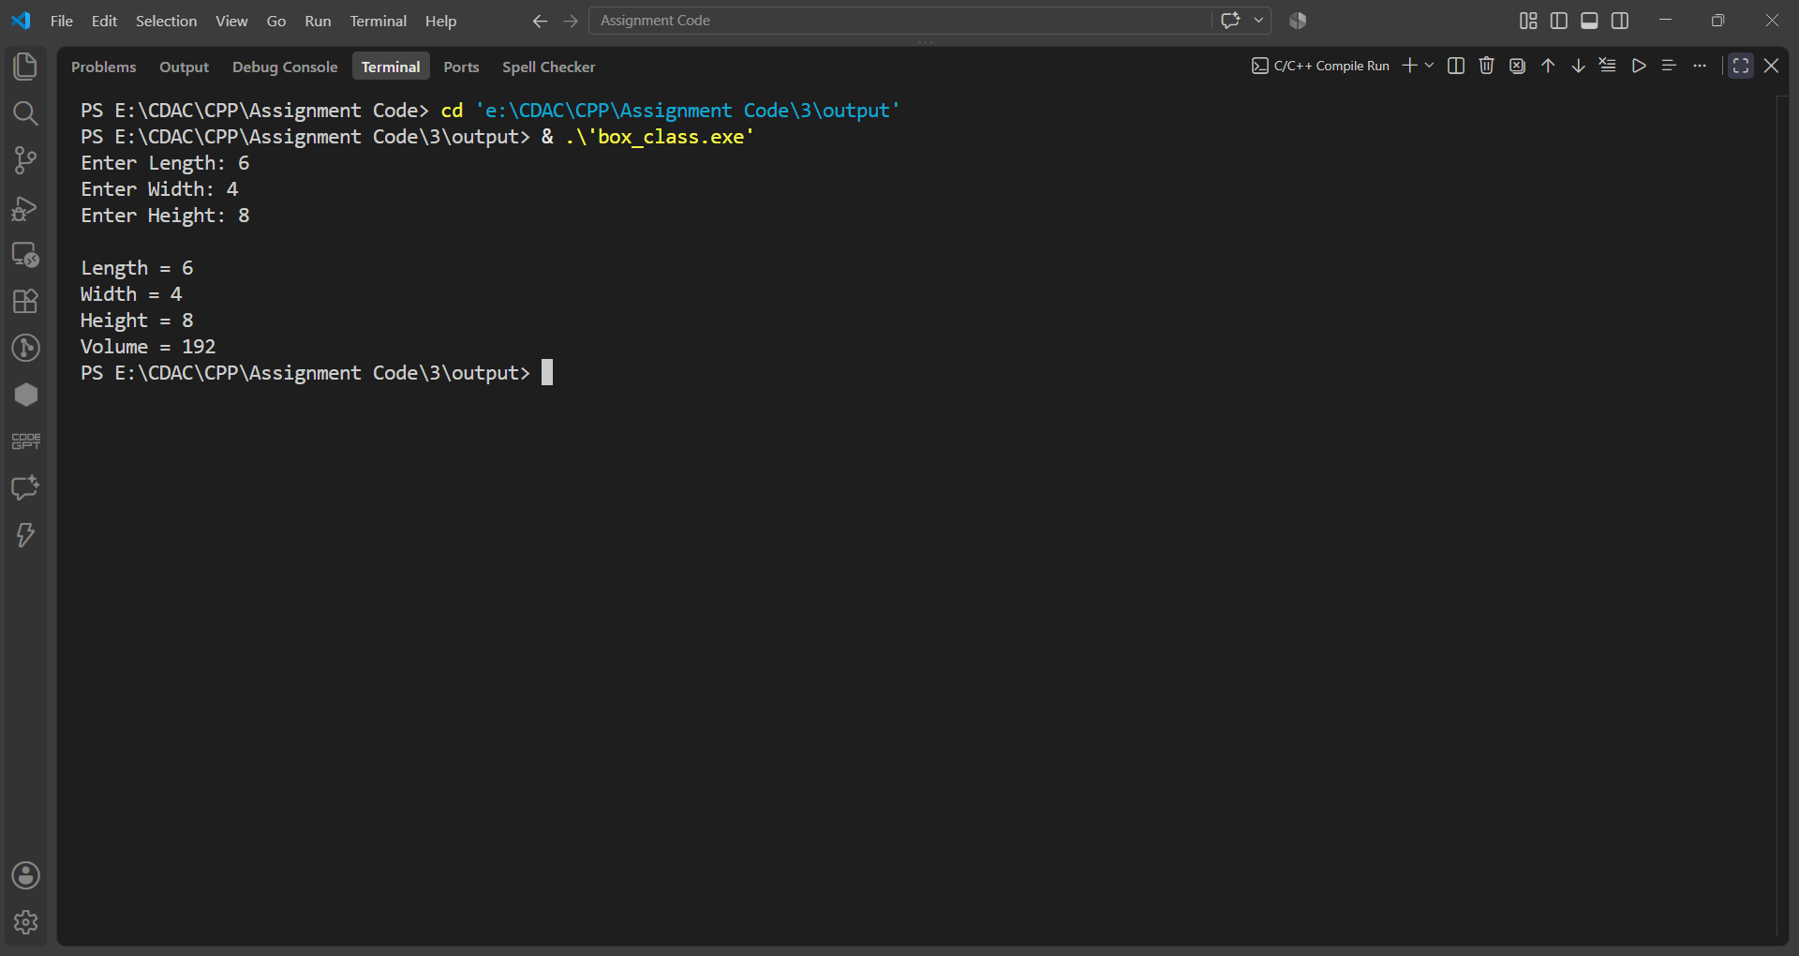

Assignment 4
Name: PRATIK SUNIL ABHANG
PNR: 260740150018
Registration ID: 260640160209

Question No. 1
Question
Create an Employee class that contains an object of an Address class representing the employee's residential address. The Address class should contain area, city, and PIN code. Accept and display the complete employee and address details. Implement constructors.
Program
#include <iostream>
#include <string>
using namespace std;

class Address
{
private:
string area;
string city;
int pin;

public:
Address()
{
area = "cdac";
city = "pune";
pin = 411001;
}

Address(string a, string c, int p)
{
area = a;
city = c;
pin = p;
}

void AddressDisplay()
{
cout << area << " " << city << " " << pin;
}
};

class Employee
{
private:
int eid;
string name;
float salary;
Address add;

public:
Employee()
{
eid = 101;
name = "pratik";
salary = 90000;
}

Employee(int ei, string na, float sa, string area, string city, int pin)
: add(area, city, pin)
{
eid = ei;
name = na;
salary = sa;
}

void EmployeeDisplay()
{
cout << eid << " " << name << " " << salary << " ";
add.AddressDisplay();
cout << endl;
}
};

int main()
{
cout << "\n";

Employee emp1;
cout << "Default:\n";
emp1.EmployeeDisplay();
cout << endl;

Employee emp2(102, "ram", 95000, "hinjewadi", "pune", 411057);
cout << "Parameterized:\n";
emp2.EmployeeDisplay();
cout << endl;

int ei;
string na;
float sa;
string area;
string city;
int pin;

cout << "Enter ID, Name, Salary, Area, City, Pin for Employee: ";
cin >> ei >> na >> sa >> area >> city >> pin;

Employee emp3(ei, na, sa, area, city, pin);
cout << "From User:\n";
emp3.EmployeeDisplay();
cout << "\n";

return 0;
}

Input & Output
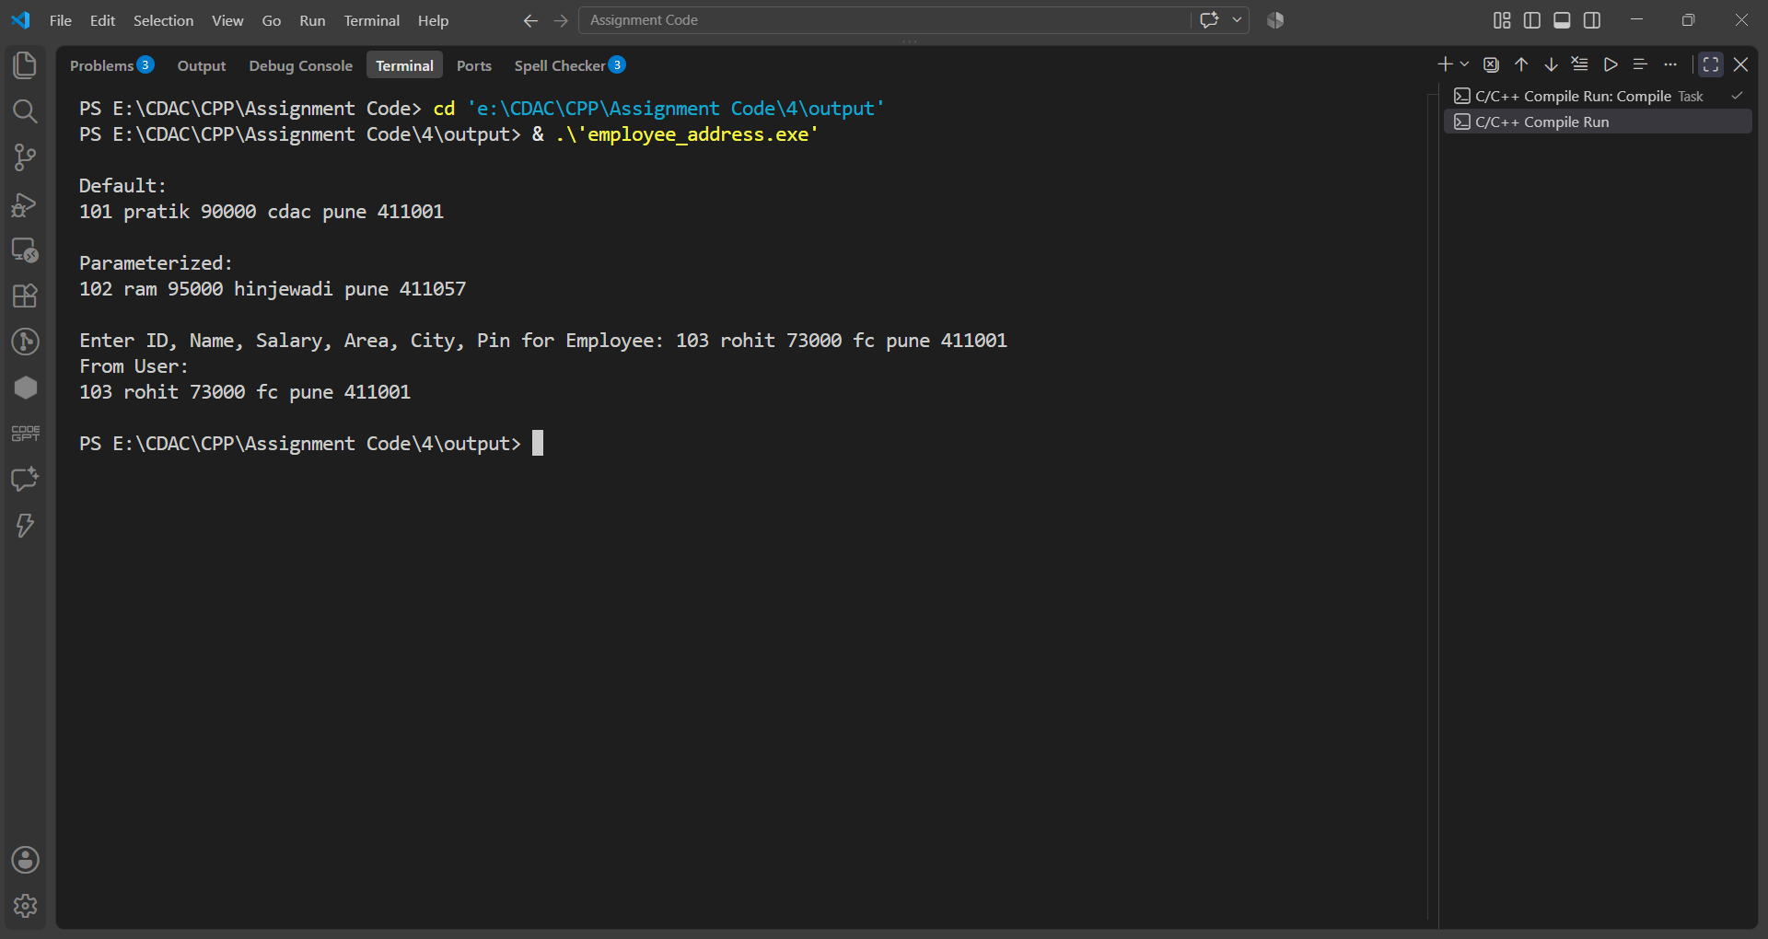

Question No. 2
Question
Create a Book class that contains an object of a Publisher class representing the publisher details. The Publisher class should contain publisher name, city, and contact number. Accept and display the book details along with its publisher information.
Program
#include <iostream>
#include <string>
using namespace std;

class Publisher
{
private:
string pname;
string city;
string contact;

public:
Publisher()
{
pname = "ABC";
city = "Pune";
contact = "9876543210";
}

Publisher(string p, string c, string con)
{
pname = p;
city = c;
contact = con;
}

void PublisherDisplay()
{
cout << pname << " " << city << " " << contact;
}
};

class Book
{
private:
int bid;
string bname;
float price;
Publisher pub;

public:
Book()
{
bid = 101;
bname = "CPP";
price = 500;
}
Book(int id, string bn, float pr, string p, string c, string con)
: pub(p, c, con)
{
bid = id;
bname = bn;
price = pr;
}

void BookDisplay()
{
cout << bid << " " << bname << " " << price << " ";
pub.PublisherDisplay();
cout << endl;
}
};

int main()
{
cout << "\n";

Book book1;
cout << "Default:\n";
book1.BookDisplay();
cout << endl;

Book book2(102, "Java", 700, "XYZ", "Mumbai", "9876543210");
cout << "Parameterized:\n";
book2.BookDisplay();
cout << endl;

int id;
string bn;
float pr;
string p;
string c;
string con;

cout << "Enter ID, Book Name, Price, Publisher Name, City, Contact: ";
cin >> id >> bn >> pr >> p >> c >> con;

Book book3(id, bn, pr, p, c, con);
cout << "From User:\n";
book3.BookDisplay();
cout << "\n";

return 0;
}
Input & Output
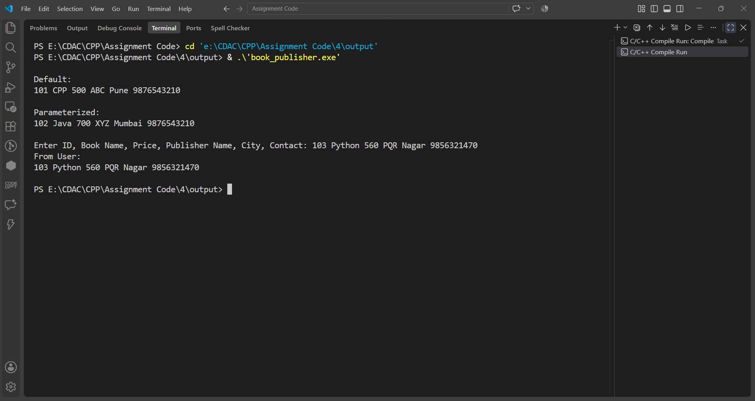

Question No. 3
Question
Create an Employee class that contains an object of a Date class representing the employee's joining date. The Date class should contain day, month, and year. Accept employee ID, employee name, salary, and joining date, and display all the details.
Program
#include <iostream>
#include <string>
using namespace std;

class Date
{
private:
int day;
int month;
int year;

public:
Date()
{
day = 21;
month = 11;
year = 2003;
}

Date(int d, int m, int y)
{
day = d;
month = m;
year = y;
}

void DateDisplay()
{
cout << " " << day << " - " << month << " - " << year;
}
};

class Employee
{
private:
int eid;
string name;
float salary;
Date doj;

public:
Employee()
{
eid = 101;
name = "pratik";
salary = 90000;
}

Employee(int ei, string na, float sa, int day, int month, int year)
: doj(day, month, year)
{
eid = ei;
name = na;
salary = sa;
}

void EmployeeDisplay()
{
cout << eid << " " << name << " " << salary;
doj.DateDisplay();
cout << endl;
}
};

int main()
{
cout << "\n";

Employee emp1;
cout << "Default:\n";
emp1.EmployeeDisplay();
cout << endl;

Employee emp2(102, "ram", 95000, 22, 7, 2026);
cout << "Parameterized:\n";
emp2.EmployeeDisplay();
cout << endl;

int ei;
string na;
float sa;
int day;
int month;
int year;

cout << "Enter ID, Name, Salary, Day, Month, Year for Employee: ";
cin >> ei >> na >> sa >> day >> month >> year;

Employee emp3(ei, na, sa, day, month, year);
cout << "From User:\n";
emp3.EmployeeDisplay();
cout << "\n";
return 0;
}
Input & Output
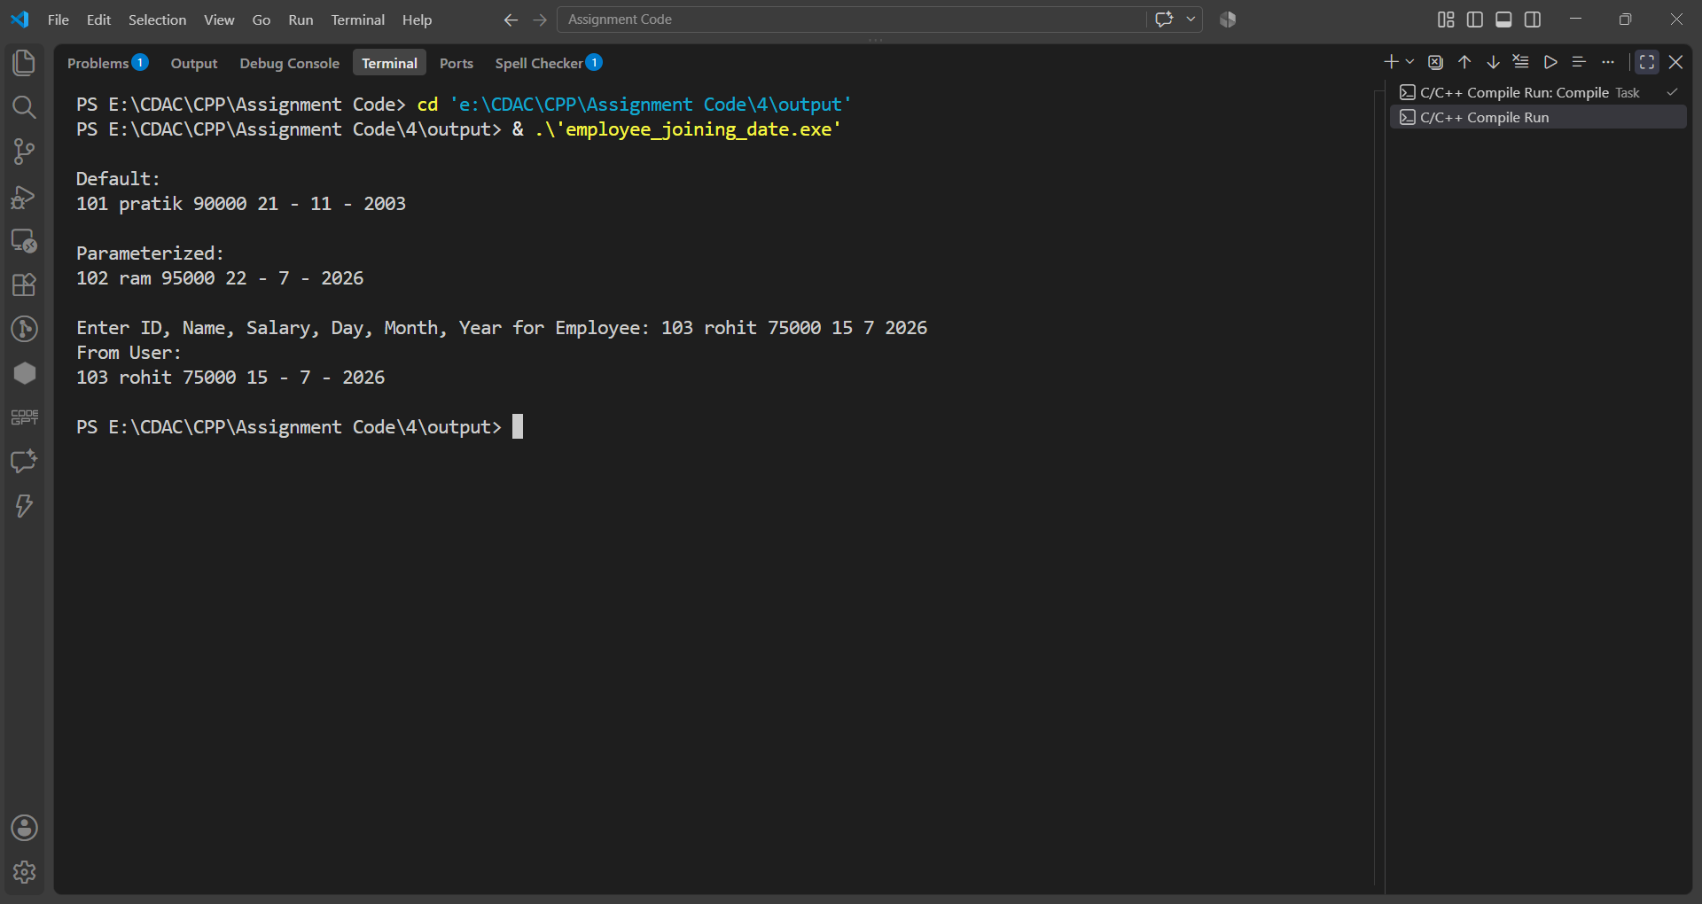

Assignment 5
Name: PRATIK SUNIL ABHANG
PNR: 260740150018
Registration ID: 260640160209

Question No. 1
Question
Create a Complex class to represent complex numbers using real and imaginary parts. Overload the following operators to perform the corresponding operations on two complex number objects:
- – Addition of two complex numbers
* – Subtraction of two complex numbers
++ – Pre Increment the real and imaginary parts of a complex number
++ – PostIncrement the real and imaginary parts of a complex number
<< and >> operator
Create appropriate objects and demonstrate the working of all the overloaded operators.
Program
#include <iostream>
using namespace std;

class Complex
{
private:
int real;
int imag;

public:
Complex()
{
this->real = 0;
this->imag = 0;
}

Complex(int real, int imag)
{
this->real = real;
this->imag = imag;
}

void Display()
{
cout << " " << this->real << " + " << this->imag << "i";
}

Complex operator+(Complex other)
{
Complex temp;

temp.real = this->real + other.real;
temp.imag = this->imag + other.imag;

return temp;
}

Complex operator-(Complex other)
{
Complex temp;

temp.real = this->real - other.real;
temp.imag = this->imag - other.imag;

return temp;
}

Complex operator++()
{
this->real = this->real + 1;
this->imag = this->imag + 1;

return *this;
}

Complex operator++(int)
{
Complex temp = *this;

this->real = this->real + 1;
this->imag = this->imag + 1;

return temp;
}

Complex operator--()
{
this->real = this->real - 1;
this->imag = this->imag - 1;

return *this;
}

Complex operator--(int)
{
Complex temp = *this;

this->real = this->real - 1;
this->imag = this->imag - 1;

return temp;
}

friend ostream &operator<<(ostream &os, Complex c)
{
os << c.real << " + " << c.imag << "i";
return os;
}

friend istream &operator>>(istream &is, Complex &c)
{
is >> c.real >> c.imag;
return is;
}
};

int main()
{
cout << endl;

Complex defaultObj;
Complex c1, c2;

defaultObj = Complex();

cout << "Default Object:";
defaultObj.Display();

cout << "\n------------------------" << endl;
c1 = Complex(10, 20);
cout << "Object 1 (c1):";
c1.Display();
cout << "\n------------------------" << endl;
c2 = Complex(5, 8);
cout << "Object 2 (c2):";
c2.Display();
cout << "\n------------------------" << endl;
Complex add = c1 + c2;
cout << "Addition (c1 + c2):";
add.Display();
cout << "\n------------------------" << endl;
Complex sub = c1 - c2;
cout << "Subtraction (c1 - c2):";
sub.Display();
cout << "\n------------------------" << endl;
Complex preInc = ++c1;
cout << "Prefix Increment (++c1):";
preInc.Display();
cout << "\n------------------------" << endl;
Complex postInc = c2++;
cout << "Postfix Increment (c2++):";
postInc.Display();
cout << endl;
cout << "After Postfix Increment c2:";
c2.Display();
cout << "\n------------------------" << endl;
Complex preDec = --c1;
cout << "Prefix Decrement (--c1):";
preDec.Display();
cout << "\n------------------------" << endl;
Complex postDec = c2--;
cout << "Postfix Decrement (c2--):";
postDec.Display();
cout << endl;
cout << "After Postfix Decrement c2:";
c2.Display();
cout << "\n------------------------" << endl;
cout << "Using ostream (<<): ";
cout << c1;
cout << "\n------------------------" << endl;
cout << "Enter real and imaginary values for c1: ";
cin >> c1;
cout << "Using istream (>>): ";
cout << c1;
cout << endl;

return 0;
}

Input & Output
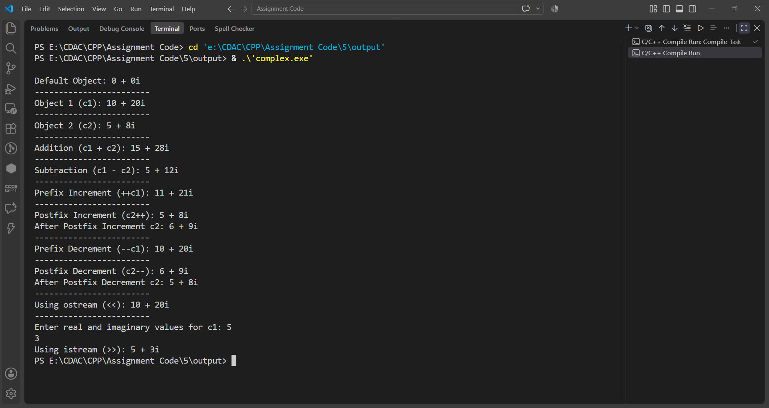

Question No. 2
Question
Create a Box class with data members length, width, and height. Define a member function to calculate the volume of a box. Overload the > operator to compare two Box objects based on their volumes. Display which box has the greater volume.
Program
#include <iostream>
using namespace std;

class Box
{
private:
int length;
int width;
int height;

public:
Box()
{
this->length = 0;
this->width = 0;
this->height = 0;
}

Box(int length, int width, int height)
{
this->length = length;
this->width = width;
this->height = height;
}

int Volume()
{
return this->length * this->width * this->height;
}

void Display()
{
cout << "Length : " << this->length << endl;
cout << "Width : " << this->width << endl;
cout << "Height : " << this->height << endl;
cout << "Volume : " << this->Volume() << endl;
}

bool operator>(Box other)
{
return this->Volume() > other.Volume();
}
};

int main()
{
cout << endl;

Box b1;

cout << "Default Object b1:" << endl;
b1.Display();

cout << "\n------------------------" << endl;

Box b2(10, 5, 4);

cout << "Parameterized Object b2:" << endl;
b2.Display();

cout << "\n------------------------" << endl;

int length;
int width;
int height;

cout << "Enter Length, Width and Height for b1: ";
cin >> length >> width >> height;

b1 = Box(length, width, height);

cout << "\nUser Input Object b1:" << endl;
b1.Display();

cout << "\n------------------------" << endl;

cout << "Comparing b1 and b2:" << endl;

if (b1 > b2)
{
cout << "Box b1 has greater volume." << endl;
}
else if (b2 > b1)
{
cout << "Box b2 has greater volume." << endl;
}
else
{
cout << "Both boxes have equal volume." << endl;
}
cout << "\n------------------------" << endl;

return 0;
}
Input & Output
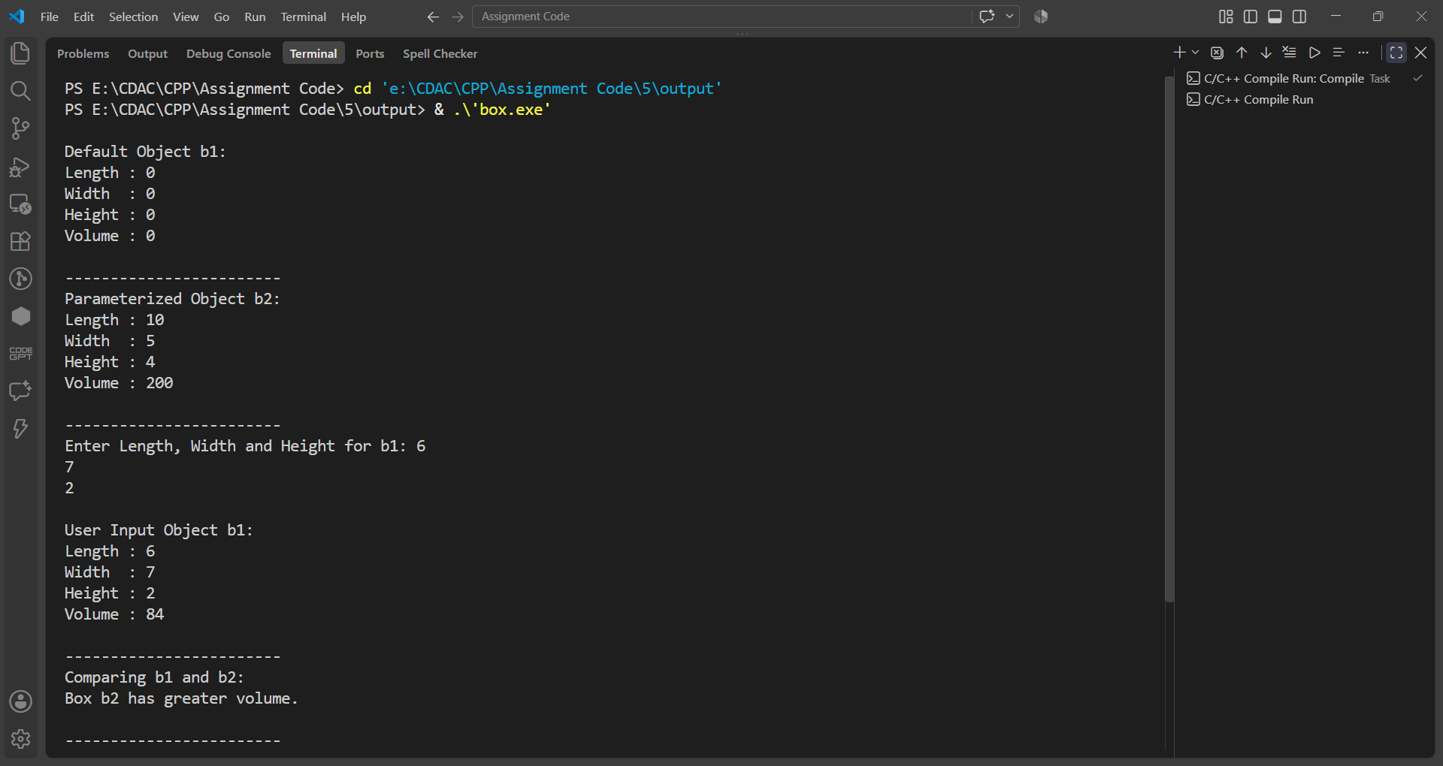

Question No. 3
Question
Create Array class Implement following.
Accept and Display function
Operator + for adding two arrays.
implement copy constructor.
implement destructor.
overload > operator.
Program
#include <iostream>
using namespace std;

class Array
{
private:
int *arr;
int size;

public:
Array()
{
this->size = 5;
this->arr = new int[this->size];

for (int i = 0; i < this->size; i++)
{
this->arr[i] = 0;
}
}

Array(const Array &other)
{
this->size = other.size;
this->arr = new int[this->size];

for (int i = 0; i < this->size; i++)
{
this->arr[i] = other.arr[i];
}
}

void Accept()
{
cout << "Enter 5 elements: ";

for (int i = 0; i < this->size; i++)
{
cin >> this->arr[i];
}
}

void Display()
{
for (int i = 0; i < this->size; i++)
{
cout << this->arr[i] << " ";
}

cout << endl;
}

void Merge(Array other)
{
for (int i = 0; i < this->size; i++)
{
cout << this->arr[i] << " ";
}

for (int i = 0; i < other.size; i++)
{
cout << other.arr[i] << " ";
}

cout << endl;
}

Array operator+(Array other)
{
Array temp;

for (int i = 0; i < this->size; i++)
{
temp.arr[i] = this->arr[i] + other.arr[i];
}

return temp;
}

Array operator-(Array other)
{
Array temp;

for (int i = 0; i < this->size; i++)
{
temp.arr[i] = this->arr[i] - other.arr[i];
}

return temp;
}

~Array()
{
delete[] this->arr;
}
};

int main()
{
cout << endl;

Array a1;
Array a2;

cout << "Array 1:" << endl;
a1.Accept();
cout << "Array 1 elements: ";
a1.Display();
cout << "\n------------------------" << endl;
cout << "Array 2:" << endl;
a2.Accept();
cout << "Array 2 elements: ";
a2.Display();
cout << "\n------------------------" << endl;
cout << "Merged Array: ";
a1.Merge(a2);
cout << "\n------------------------" << endl;
Array a3 = a1 + a2;
cout << "Addition (Array 1 + Array 2): ";
a3.Display();
cout << "\n------------------------" << endl;
Array a4 = a1 - a2;
cout << "Subtraction (Array 1 - Array 2): ";
a4.Display();
cout << "\n------------------------" << endl;
Array a5 = a1;
cout << "Copy Constructor Array: ";
a5.Display();
cout << "\n------------------------" << endl;

return 0;
}

Input & Output
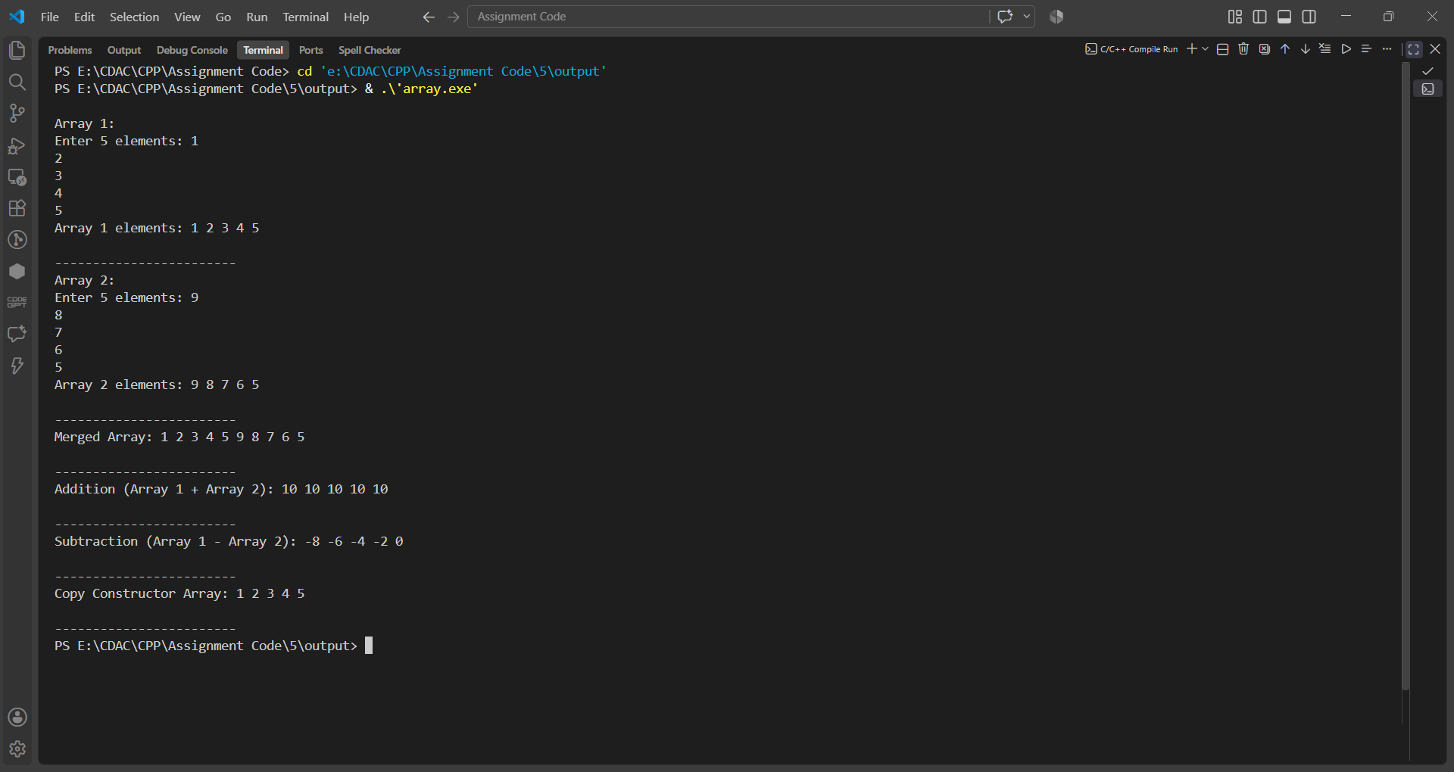

Assignment 6
Name: PRATIK SUNIL ABHANG
PNR: 260740150018
Registration ID: 260640160209

Question No. 1
Question
Write a C++ program to demonstrate inheritance by creating a Person base class and a Student derived class, accepting and displaying student details including name, age, roll number, and percentage.
Program
#include <iostream>
#include <string>

using namespace std;

class Person
{
protected:
int age;
string name;

public:
Person()
{
age = 0;
name = "";
}

void Accept()
{
cout << "Enter name: ";
cin >> name;

cout << "Enter age: ";
cin >> age;
}

void Display()
{
cout << "\n--- Person Details ---" << endl;
cout << "Name: " << name << endl;
cout << "Age: " << age << endl;
}
};

class Student : public Person
{
private:
int rno;
float percentage;

public:
Student() : Person()
{
rno = 0;
percentage = 0.0;
}

void Accept()
{
Person::Accept();

cout << "Enter Roll Number: ";
cin >> rno;

cout << "Enter Percentage: ";
cin >> percentage;
}

void Display()
{
Person::Display();

cout << "Roll Number: " << rno << endl;
cout << "Percentage: " << percentage << "%" << endl;
}
};

int main()
{
Student s;

cout << "--- Enter Student Details ---" << endl;

s.Accept();

cout << "\n--- Student Details ---" << endl;

s.Display();

return 0;
}

Input & Output
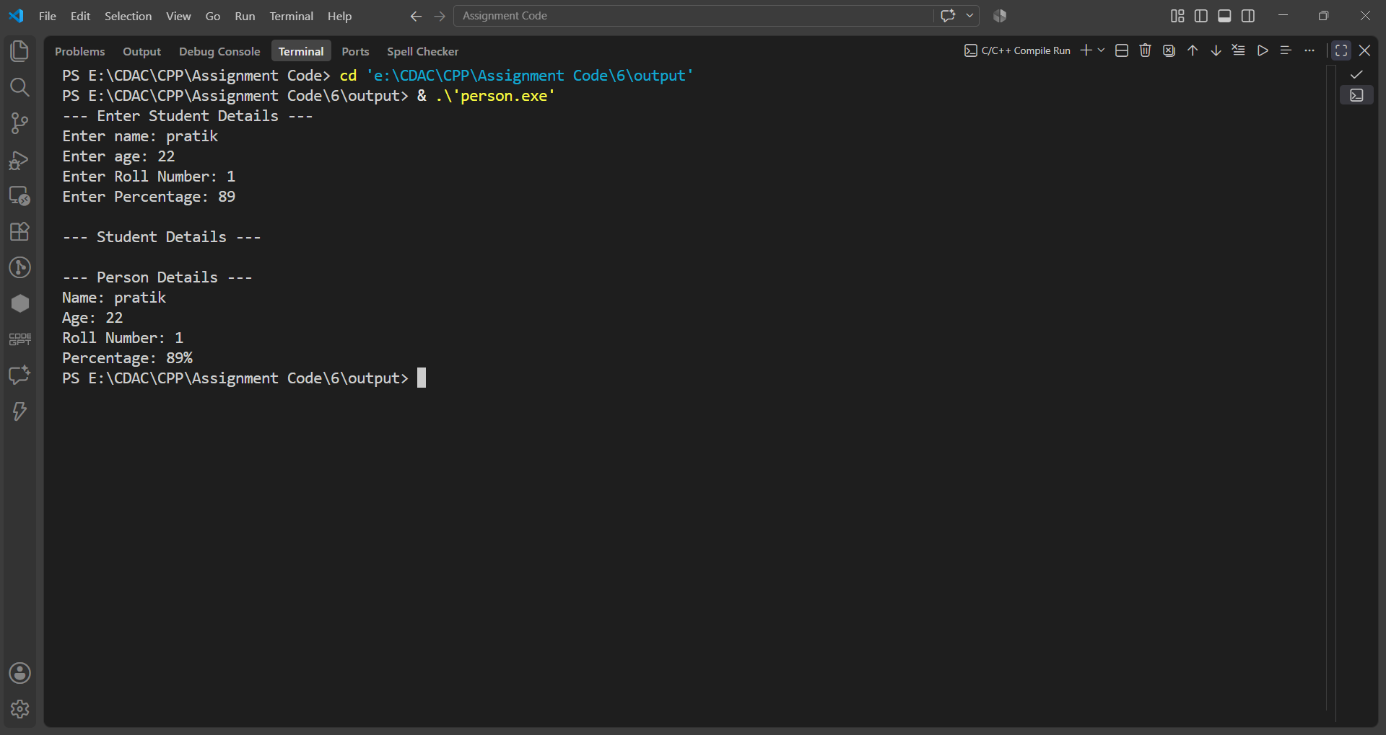

Question No. 2
Question
Write a C++ program to demonstrate abstraction and polymorphism using an abstract Shape class and derived Circle, Rectangle, and Triangle classes to calculate their respective areas.
Program
#include <iostream>
#include <string>

using namespace std;

class Shape
{
protected:
string shapeName;

public:
Shape(string name)
{
shapeName = name;
}

void DisplayShape()
{
cout << "\n--- " << shapeName << " ---" << endl;
}

virtual void Accept() = 0;
virtual void Area() = 0;
};

class Circle : public Shape
{
private:
double radius;

public:
Circle() : Shape("Circle")
{
radius = 0.0;
}

void Accept() override
{
cout << "Enter radius: ";
cin >> radius;
}

void Area() override
{
cout << "Area of Circle: " << (3.14 * radius * radius) << endl;
}
};

class Rectangle : public Shape
{
private:
double length;
double breadth;

public:
Rectangle() : Shape("Rectangle")
{
length = 0.0;
breadth = 0.0;
}

void Accept() override
{
cout << "Enter length: ";
cin >> length;

cout << "Enter breadth: ";
cin >> breadth;
}

void Area() override
{
cout << "Area of Rectangle: " << (length * breadth) << endl;
}
};

class Triangle : public Shape
{
private:
double base;
double height;

public:
Triangle() : Shape("Triangle")
{
base = 0.0;
height = 0.0;
}

void Accept() override
{
cout << "Enter base: ";
cin >> base;

cout << "Enter height: ";
cin >> height;
}

void Area() override
{
cout << "Area of Triangle: " << (0.5 * base * height) << endl;
}
};

int main()
{
Circle c;
Rectangle r;
Triangle t;

Shape *shapes[3];

shapes[0] = &c;
shapes[1] = &r;
shapes[2] = &t;

int ch;

do
{
cout << "\n--- MENU ---" << endl;
cout << "1. Circle" << endl;
cout << "2. Rectangle" << endl;
cout << "3. Triangle" << endl;
cout << "4. Exit" << endl;

cout << "Enter choice: ";
cin >> ch;

switch (ch)
{
case 1:
shapes[0]->Accept();
shapes[0]->DisplayShape();
shapes[0]->Area();
break;

case 2:
shapes[1]->Accept();
shapes[1]->DisplayShape();
shapes[1]->Area();
break;

case 3:
shapes[2]->Accept();
shapes[2]->DisplayShape();
shapes[2]->Area();
break;

case 4:
cout << "Bye" << endl;
break;

default:
cout << "Invalid choice!" << endl;
}

} while (ch != 4);

return 0;
}

Input & Output
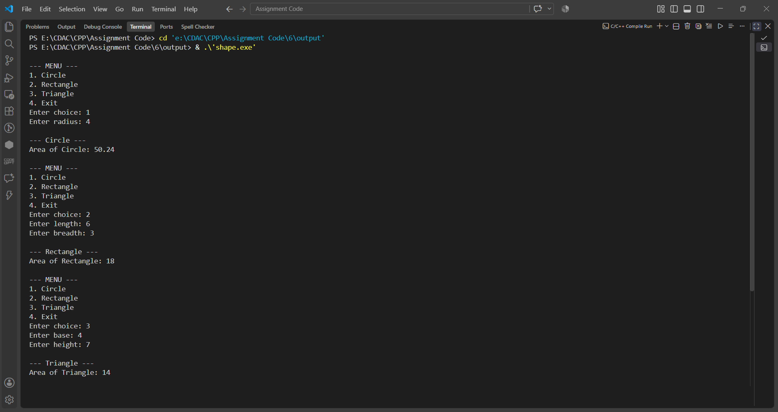

Question No. 3
Question
Write a C++ program to demonstrate inheritance and runtime polymorphism using an Employee base class and Manager, Developer, and SalesEmployee derived classes to accept employee details and calculate salary.
Program
#include <iostream>
#include <string>

using namespace std;

class Employee
{
protected:
int employeeId;
string employeeName;
double basicSalary;

public:
Employee()
{
employeeId = 0;
employeeName = "";
basicSalary = 0.0;
}

virtual void Accept()
{
cout << "Enter Employee ID: ";
cin >> employeeId;

cout << "Enter Employee Name: ";
cin >> employeeName;

cout << "Enter Basic Salary: ";
cin >> basicSalary;
}

virtual void Display()
{
cout << "Employee ID: " << employeeId << endl;
cout << "Employee Name: " << employeeName << endl;
cout << "Basic Salary: " << basicSalary << endl;
}

virtual double calculateSalary() = 0;
};

class Manager : public Employee
{
private:
double allowance;

public:
Manager() : Employee()
{
allowance = 0.0;
}

void Accept() override
{
Employee::Accept();

cout << "Enter Allowance: ";
cin >> allowance;
}

void Display() override
{
cout << "\n--- Manager Details ---" << endl;

Employee::Display();

cout << "Allowance: " << allowance << endl;
}

double calculateSalary() override
{
return basicSalary + allowance;
}
};

class Developer : public Employee
{
private:
double bonus;

public:
Developer() : Employee()
{
bonus = 0.0;
}

void Accept() override
{
Employee::Accept();

cout << "Enter Bonus: ";
cin >> bonus;
}

void Display() override
{
cout << "\n--- Developer Details ---" << endl;

Employee::Display();

cout << "Bonus: " << bonus << endl;
}

double calculateSalary() override
{
return basicSalary + bonus;
}
};

class SalesEmployee : public Employee
{
private:
double salesAmount;
double commissionRate;

public:
SalesEmployee() : Employee()
{
salesAmount = 0.0;
commissionRate = 0.0;
}

void Accept() override
{
Employee::Accept();

cout << "Enter Sales Amount: ";
cin >> salesAmount;

cout << "Enter Commission Rate: ";
cin >> commissionRate;
}

void Display() override
{
cout << "\n--- Sales Employee Details ---" << endl;

Employee::Display();

cout << "Sales Amount: " << salesAmount << endl;
cout << "Commission Rate: " << commissionRate << endl;
}

double calculateSalary() override
{
return basicSalary + (salesAmount * commissionRate);
}
};

int main()
{
int size;

cout << "Enter size of employee array: ";
cin >> size;

if (size <= 0)
{
cout << "Invalid array size!" << endl;
return 1;
}

Employee *employees[size];

for (int i = 0; i < size; i++)
{
employees[i] = nullptr;
}

int count = 0;
int ch;

do
{
cout << "\n--- MENU ---" << endl;
cout << "1. Add Manager" << endl;
cout << "2. Add Developer" << endl;
cout << "3. Add Sales Employee" << endl;
cout << "4. Exit" << endl;

cout << "Enter choice: ";
cin >> ch;

switch (ch)
{
case 1:

if (count >= size)
{
cout << "Array is full!" << endl;
}
else
{
Manager m;

m.Accept();

employees[count] = &m;

employees[count]->Display();

cout << "Calculated Salary: "
<< employees[count]->calculateSalary()
<< endl;

count++;
}

break;

case 2:

if (count >= size)
{
cout << "Array is full!" << endl;
}
else
{
Developer d;

d.Accept();

employees[count] = &d;

employees[count]->Display();

cout << "Calculated Salary: "
<< employees[count]->calculateSalary()
<< endl;

count++;
}

break;

case 3:

if (count >= size)
{
cout << "Array is full!" << endl;
}
else
{
SalesEmployee s;

s.Accept();

employees[count] = &s;

employees[count]->Display();

cout << "Calculated Salary: "
<< employees[count]->calculateSalary()
<< endl;

count++;
}

break;

case 4:

cout << "Bye" << endl;

break;

default:

cout << "Invalid Choice!" << endl;
}

} while (ch != 4);

return 0;
}

Input & Output
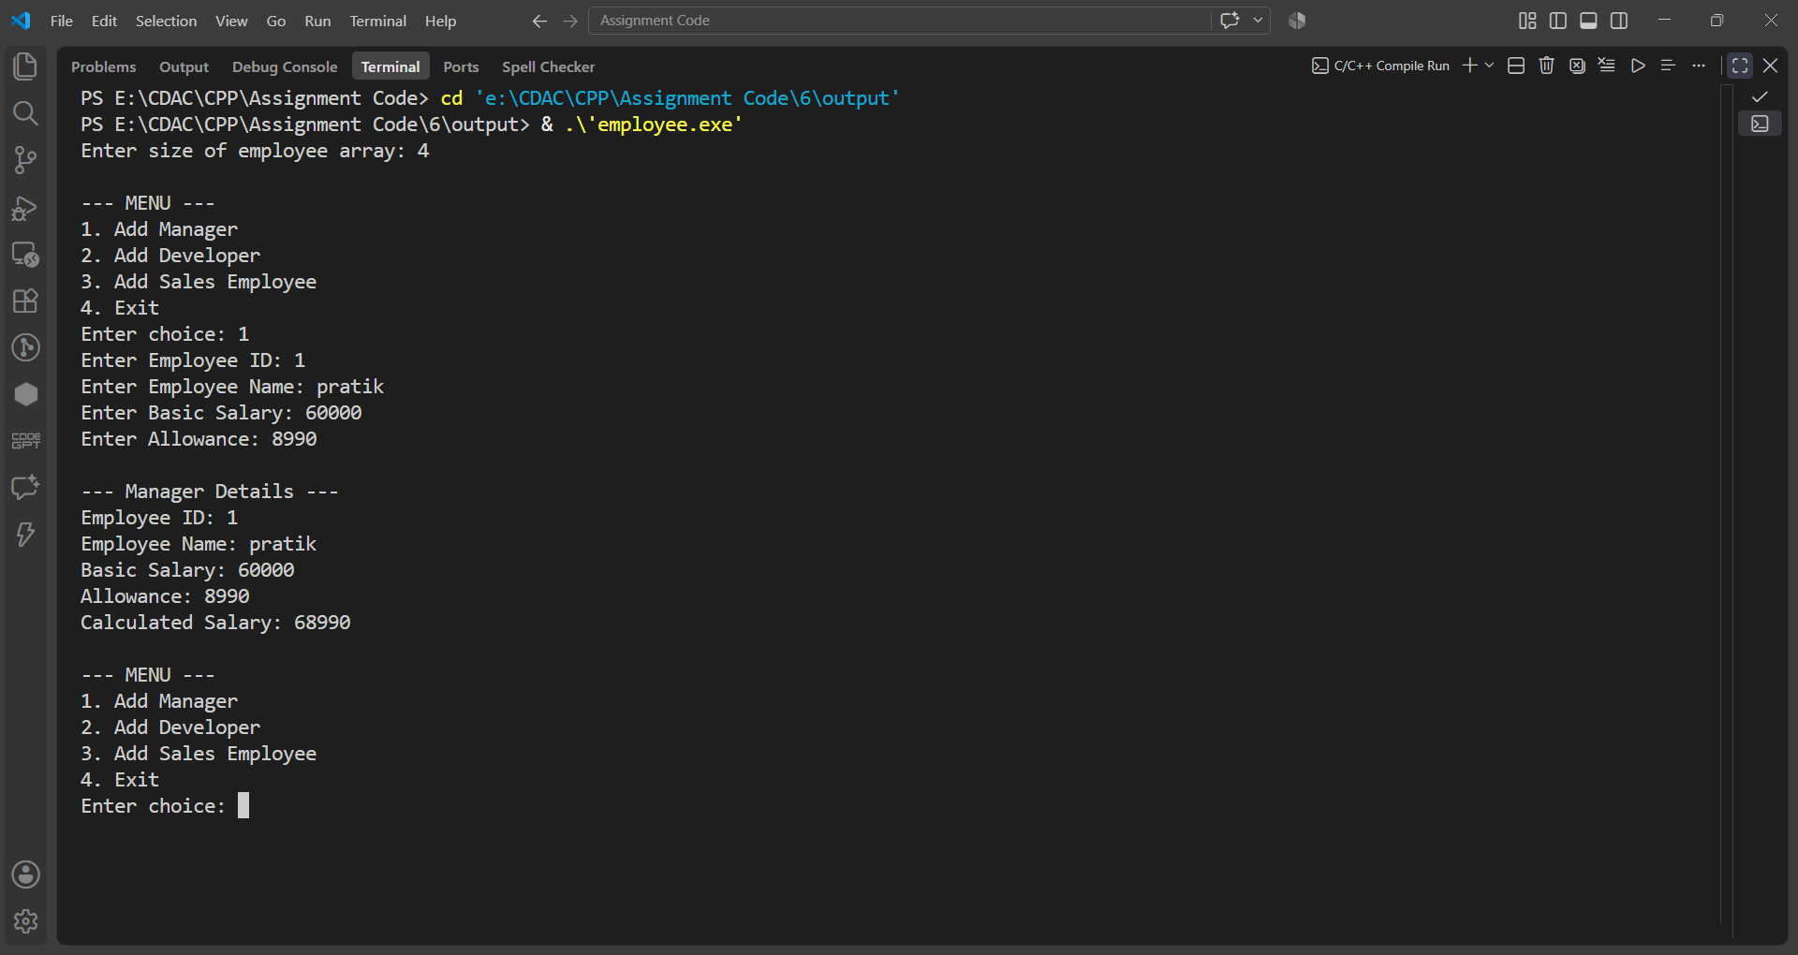

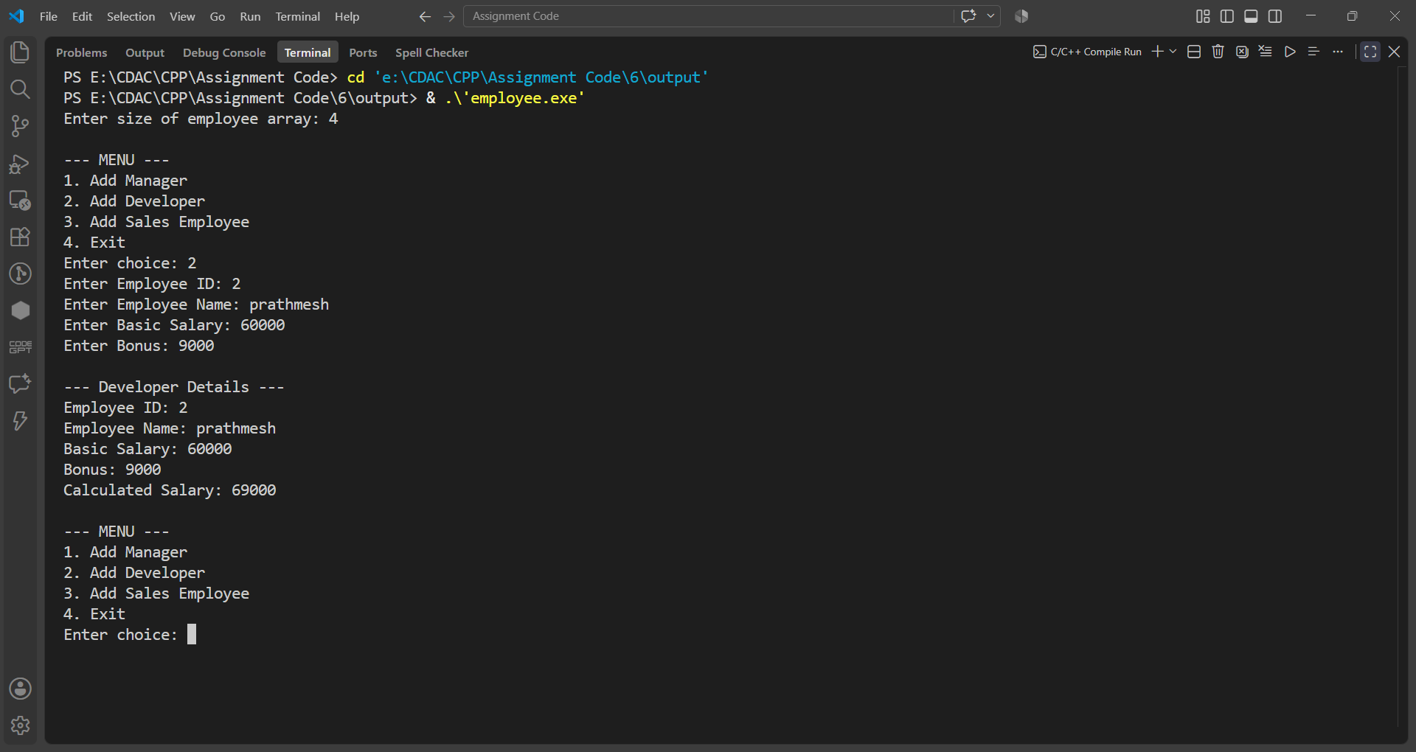

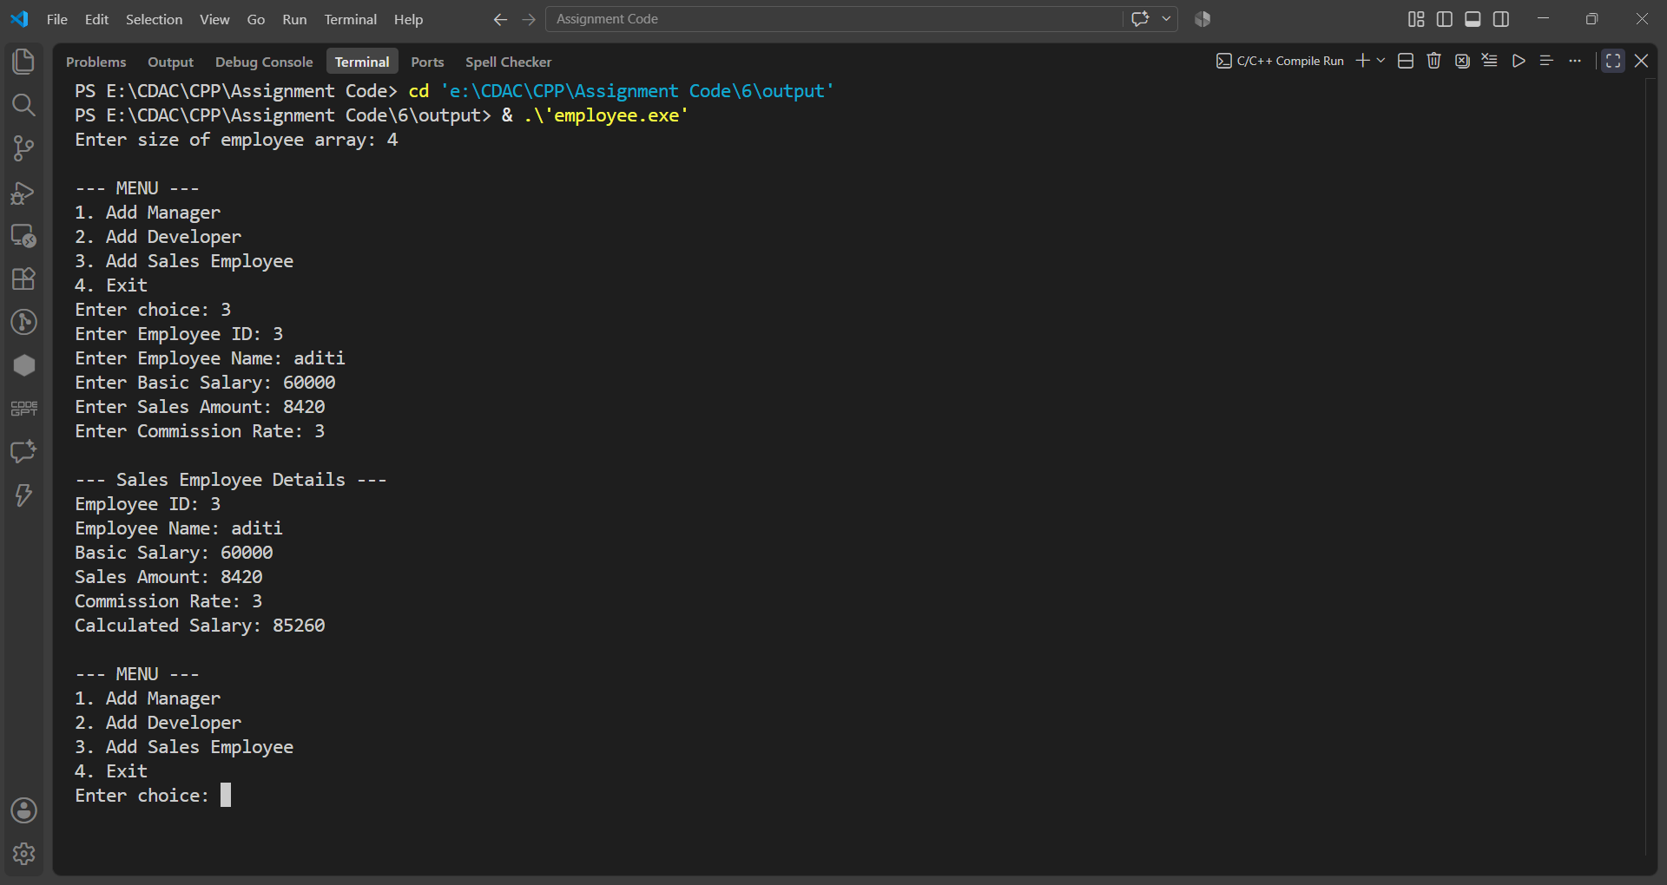

Assignment 7
Name: PRATIK SUNIL ABHANG
PNR: 260740150018
Registration ID: 260640160209

Question No. 1
Question
Create a Banking Management System using object-oriented programming concepts.
Create a base class Account containing account number, customer name, and balance.
Derive classes SavingsAccount and CurrentAccount from Account.
Implement functions such as deposit(), withdraw(), and displayAccountDetails().
Override the withdraw() function in both derived classes to demonstrate runtime polymorphism.
Use a base-class pointer to call the appropriate derived-class functions.
Apply the following validations using exception handling:
Attempt to withdraw an amount greater than the available balance.
Deposit amount should be greater than zero.
Withdraw amount should be greater than zero.
Account number should be valid.
Create and handle appropriate user-defined exceptions.
Program
#include <iostream>
#include <string>
#include <exception>
using namespace std;

class AccountException : public exception
{
private:
string message;

public:
AccountException(const string &msg) : message(msg) {}

const char *what() const noexcept override
{
return message.c_str();
}
};

class Account
{
public:
int accountNo;
string name;
double balance;

Account(int accountNo, string name, double balance)
{
if (accountNo <= 0)
throw AccountException("Invalid Account Number");

if (balance < 0)
throw AccountException("Balance cannot be negative");

this->accountNo = accountNo;
this->name = name;
this->balance = balance;
}

virtual ~Account() = default;

void deposit(double amount)
{
if (amount <= 0)
throw AccountException("Deposit amount must be greater than zero");

balance += amount;
cout << "Deposit successful\n";
}

virtual void withdraw(double amount) = 0;

virtual void displayAccountDetails()
{
cout << "\nAccount No : " << accountNo;
cout << "\nName : " << name;
cout << "\nBalance : " << balance << endl;
}
};

class SavingsAccount : public Account
{
private:
double interestRate;

public:
SavingsAccount(int accountNo, string name, double balance, double interestRate)
: Account(accountNo, name, balance)
{
this->interestRate = interestRate;
}

void withdraw(double amount) override
{
if (amount <= 0)
throw AccountException("Withdraw amount must be greater than zero");

if (amount > balance)
throw AccountException("Withdrawal amount is greater than available balance");

if (balance - amount < 500)
throw AccountException("Savings Account must maintain minimum balance of 500");

balance -= amount;
cout << "Savings Account withdrawal successful\n";
}

void displayAccountDetails() override
{
cout << "\nAccount Type : Savings Account";
Account::displayAccountDetails();
cout << "Interest Rate : " << interestRate << "%\n";
}
};

class CurrentAccount : public Account
{
private:
double maintenanceFee;

public:
CurrentAccount(int accountNo, string name, double balance, double maintenanceFee)
: Account(accountNo, name, balance)
{
this->maintenanceFee = maintenanceFee;
}

void withdraw(double amount) override
{
if (amount <= 0)
throw AccountException("Withdraw amount must be greater than zero");

if (amount > balance)
throw AccountException("Withdrawal amount is greater than available balance");

balance -= amount;
cout << "Current Account withdrawal successful\n";
}

void displayAccountDetails() override
{
cout << "\nAccount Type : Current Account";
Account::displayAccountDetails();
cout << "Maintenance Fee : " << maintenanceFee << "\n";
}
};

int main()
{
Account *accounts[10] = {nullptr};
int count = 0;
int choice;

do
{
cout << "\n===== BANKING MANAGEMENT SYSTEM =====";
cout << "\n1. Create Account";
cout << "\n2. Deposit";
cout << "\n3. Withdraw";
cout << "\n4. Display All Accounts";
cout << "\n5. Exit";
cout << "\nEnter choice: ";
cin >> choice;

try
{
switch (choice)
{
case 1:
{
if (count >= 10)
throw AccountException("Cannot create more than 10 accounts");

int accountNo, type;
string name;
double balance;

cout << "Enter Account Number: ";
cin >> accountNo;

if (accountNo <= 0)
throw AccountException("Invalid Account Number");

for (int i = 0; i < count; i++)
{
if (accounts[i]->accountNo == accountNo)
throw AccountException("Account number already exists");
}

cout << "Enter Customer Name: ";
cin >> name;

cout << "Enter Initial Balance: ";
cin >> balance;

if (balance < 0)
throw AccountException("Balance cannot be negative");

cout << "\n1. Savings Account";
cout << "\n2. Current Account";
cout << "\nEnter Account Type: ";
cin >> type;

if (type == 1)
{
if (balance < 500)
throw AccountException("Savings Account must maintain minimum balance of 500");

double interestRate;
cout << "Enter Interest Rate (%): ";
cin >> interestRate;

if (interestRate < 0)
throw AccountException("Interest rate cannot be negative");

accounts[count] = new SavingsAccount(accountNo, name, balance, interestRate);
cout << "\nSavings Account created successfully\n";
count++;
}
else if (type == 2)
{
double maintenanceFee;
cout << "Enter Maintenance Fee: ";
cin >> maintenanceFee;

if (maintenanceFee < 0)
throw AccountException("Maintenance fee cannot be negative");

accounts[count] = new CurrentAccount(accountNo, name, balance, maintenanceFee);
cout << "\nCurrent Account created successfully\n";
count++;
}
else
{
throw AccountException("Invalid Account Type");
}
break;
}

case 2:
{
int accountNo;
double amount;

cout << "Enter Account Number: ";
cin >> accountNo;

cout << "Enter Deposit Amount: ";
cin >> amount;

int found = 0;
for (int i = 0; i < count; i++)
{
if (accounts[i]->accountNo == accountNo)
{
accounts[i]->deposit(amount);
found = 1;
break;
}
}

if (!found)
throw AccountException("Account not found");
break;
}

case 3:
{
int accountNo;
double amount;

cout << "Enter Account Number: ";
cin >> accountNo;

cout << "Enter Withdrawal Amount: ";
cin >> amount;

int found = 0;
for (int i = 0; i < count; i++)
{
if (accounts[i]->accountNo == accountNo)
{
accounts[i]->withdraw(amount);
found = 1;
break;
}
}

if (!found)
throw AccountException("Account not found");
break;
}

case 4:
{
if (count == 0)
{
cout << "No accounts available\n";
}
else
{
for (int i = 0; i < count; i++)
{
accounts[i]->displayAccountDetails();
}
}
break;
}

case 5:
cout << "Thank you for using Banking Management System!\n";
break;

default:
throw AccountException("Invalid choice");
}
}
catch (const AccountException &e)
{
cout << "\nError: " << e.what() << endl;
}
catch (const exception &e)
{
cout << "\nError: " << e.what() << endl;
}

} while (choice != 5);

for (int i = 0; i < count; i++)
{
delete accounts[i];
}

return 0;
}

Input & Output
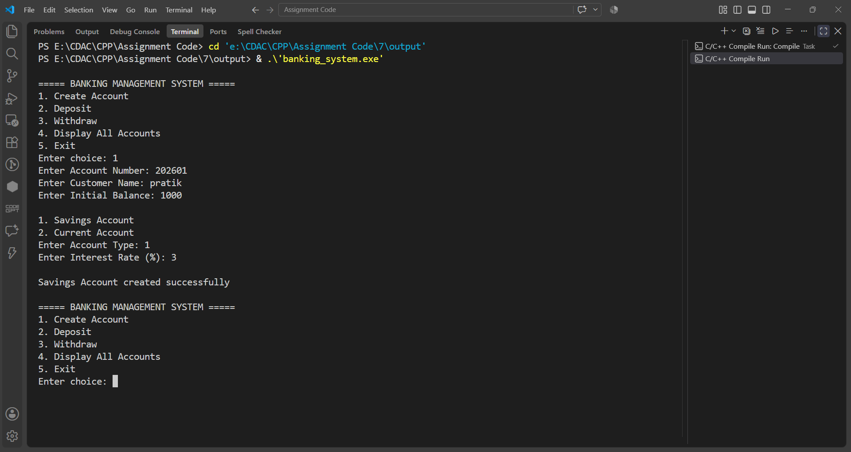

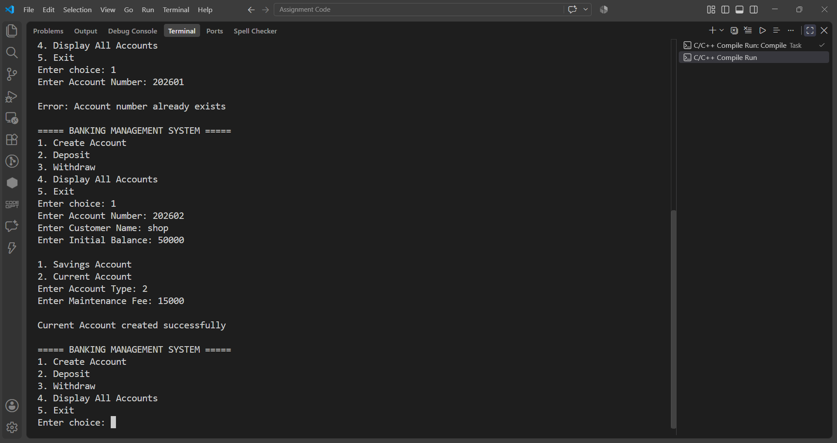

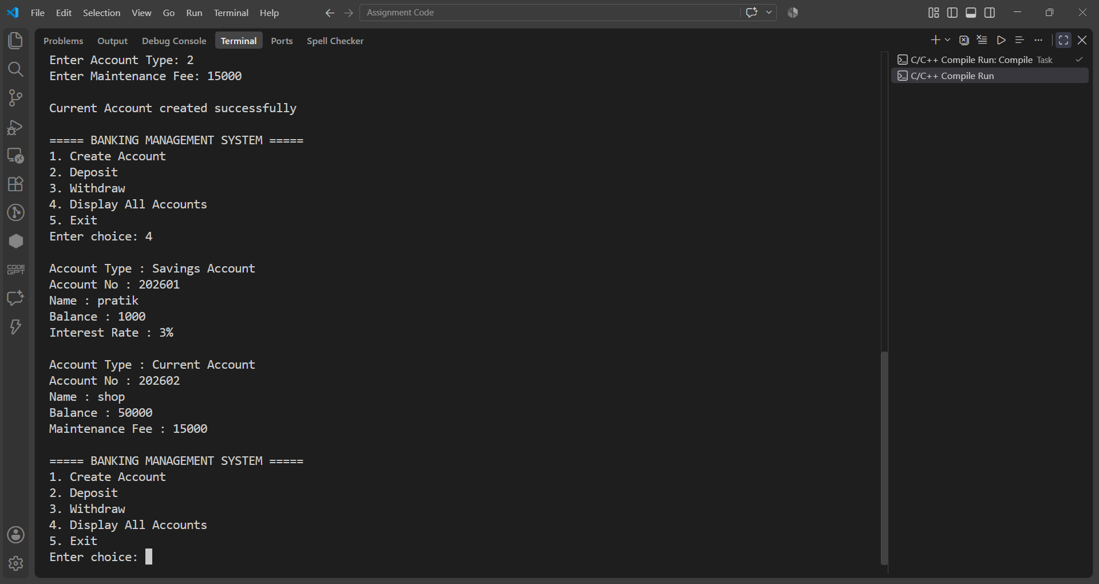

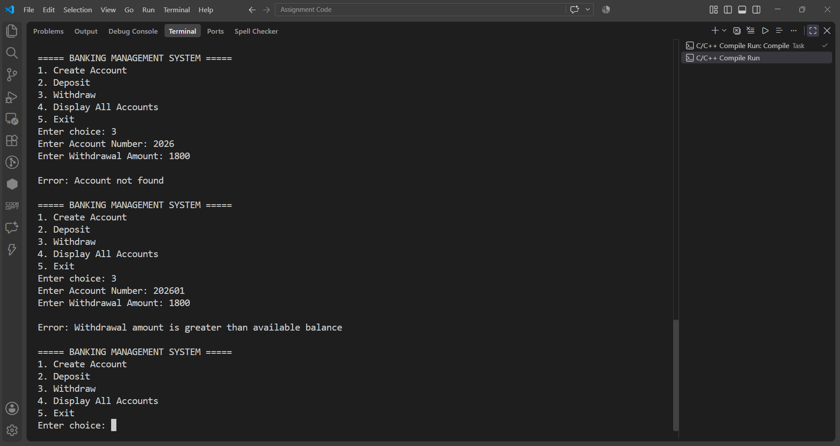

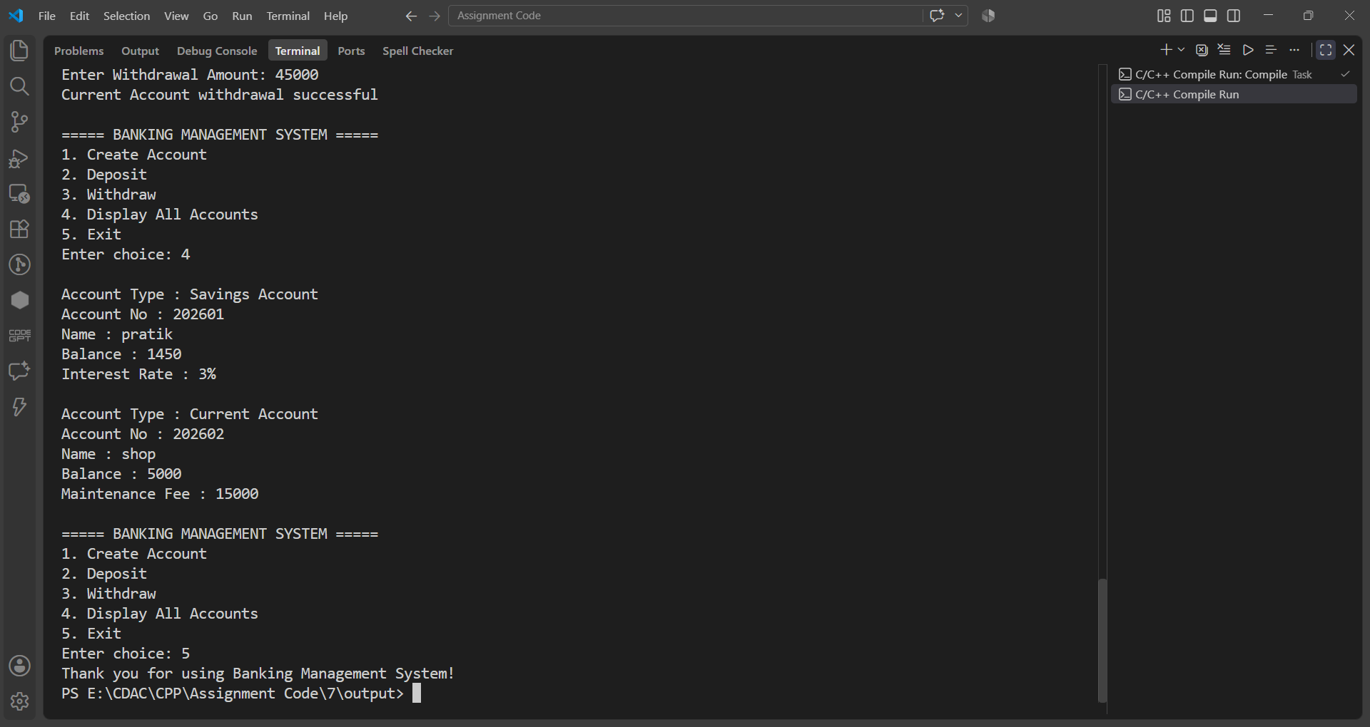

Question No. 2
Question
Division by Zero
Write a C++ program to accept two integers from the user and perform division. Use exception handling to handle the situation when the denominator is zero.
Requirements:
Accept numerator and denominator.
If denominator is 0, throw an exception.
Display an appropriate error message using catch.
Otherwise, display the result.
Program
#include <iostream>
#include <exception>
using namespace std;

class DivisionByZeroException : public exception
{
public:
const char *what() const noexcept override
{
return "Division by zero is not allowed";
}
};

int main()
{
int numerator, denominator;

cout << "\n\tEnter Numerator and Denominator: ";
cin >> numerator >> denominator;

try
{
if (denominator == 0)
throw DivisionByZeroException();

cout << "\n\tResult: " << numerator / denominator << endl;
}
catch (const DivisionByZeroException &e)
{
cout << "\n\tError: " << e.what() << endl;
}
catch (const exception &e)
{
cout << "\n\tError: " << e.what() << endl;
}

return 0;
}

Input & Output
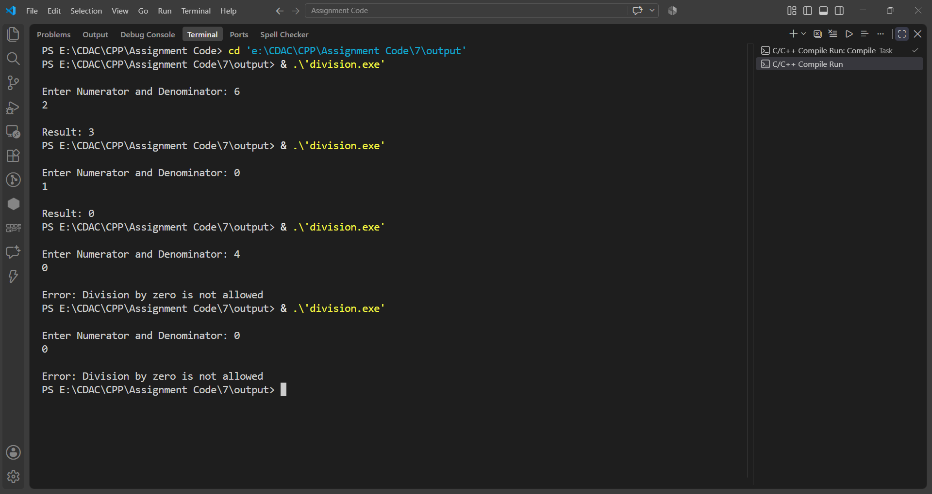

Question No. 3
Question
Array Index Validation
Write a C++ program to create an integer array of size 10. Accept an index from the user and display the element at that index.
If the user enters an index outside the valid range 0–9, throw an exception.
Requirements:
Create an array of 10 integers.
Accept an index from the user.
Use try, throw, and catch.
Display the corresponding element for a valid index.
Display "Invalid Array Index" for an invalid index.
Program
#include <iostream>
#include <stdexcept>
using namespace std;

int main()
{
int arr[] = {43, 54, 76, 23, 65, 2, 45, 56, 22, 5};
int index;

try
{
cout << "\n\tEnter The Index Number: ";
cin >> index;

if (index < 0 || index >= 10)
throw out_of_range("Invalid Array Index");

cout << "\n\tValue At " << index << " Is " << arr[index];
}
catch (const out_of_range &e)
{
cout << "\n\tERROR : " << e.what();
}

cout << "\n\n\n";
return 0;
}

Input & Output
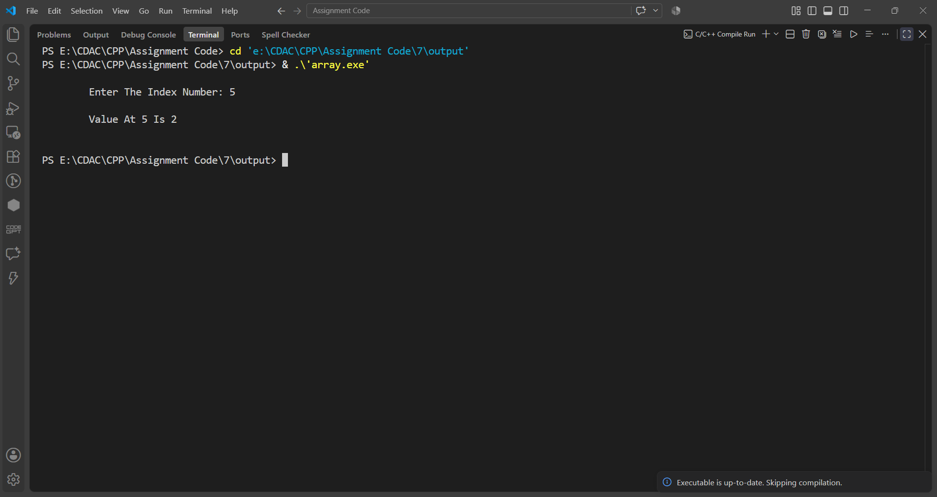

Question No. 4
Question
Friend Class
Box and BoxCalculator
Suppose the Box class contains private dimensions. We want another class, BoxCalculator, to access those private members and calculate the volume.
Program
#include <iostream>
using namespace std;

class Box
{
private:
int length, width, height;
public:
Box()
{
length = 0;
width = 0;
height = 0;
}
Box(int l, int w, int h)
{
length = l;
width = w;
height = h;
}
friend class BoxCalculator;
};
class BoxCalculator
{
public:
void calculateVolume(const Box &b)
{
int volume = b.length * b.width * b.height;
cout << "\n\t========== BOX DETAILS ==========";
cout << "\n\tBox Length : " << b.length;
cout << "\n\tBox Width : " << b.width;
cout << "\n\tBox Height : " << b.height;
cout << "\n\tBox Volume : " << volume;
}
};
int main()
{
Box b1(10, 4, 5);
BoxCalculator calc;
calc.calculateVolume(b1);
return 0;
}

Input & Output
